Use the eight points of the compass, six-figure grid references, symbols, and keys to build knowledge of the areas studied.


Year 6 Geography- Amazing Argentina
Outcome: Create a travel brochure for Argentina

Prior knowledge and skills
 | - Use maps, atlases, globes and digital/computer mapping to locate countries and describe features studied in the context of food miles.
 | - Name and locate counties and cities of the United Kingdom, geographical regions and their identifying human and physical characteristics, key topographical features (including hills, mountains, coasts and rivers), and land-use patterns; and understand how some of these aspects have changed over time in the context of UK power stations
 | - Describe and understand key aspects of human geography, including: types of settlement and land use, economic activity including trade links, and the distribution of natural resources including energy, food, minerals and water in the context of renewable and non-renewable energy sources.

Vocabulary:
Physical: altitude, biodiverse, biome, climate, continent, endangered, erosion, extinct (species), natural resource, plain, glacier, habitat, latitude, longitude
Human: agriculture, capital city, civilisation, colony, colonisation, colonist, culture, economy, deforestation, export, guacho, industry, manufacturing, poverty, resource distribution, rural, tango, urban

Ideas and inspiration
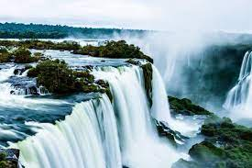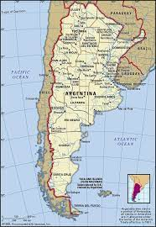

Developing Knowledge
Locational knowledge |  | Working Towards | Within | Securely Within | Above
 | - locate the world’s countries, using maps to focus on South America, concentrating on their environmental regions, key physical and human characteristics, countries, and major cities
 | - identify the position and significance of latitude, longitude, Equator, Northern Hemisphere, Southern Hemisphere, the Tropics of Cancer and Capricorn, Arctic and Antarctic Circle, the Prime/Greenwich Meridian and time zones (including day and night)
Place Knowledge |  | Working Towards | Within | Securely Within | Above
 | - understand geographical similarities and differences through a study of human and physical geography of Buenos Aires in Argentina and compare to Year 5 study: Comparing places: London and Barcelona
Human and Physical features. |  | Working Towards | Within | Securely Within | Above
 | - describe and understand key aspects of the physical geography of Argentina
 | - investigate the four major geographical regions of Argentina and their climates
 | - describe and understand key aspects of the human geography of Argentina (types of settlements and land use, economic activity and distribution of natural resources)
 | - explore the impact of humans in Argentina in the context of deforestation and other social issues
Developing skills
Map skills |  | Working Towards | Within | Securely Within | Above
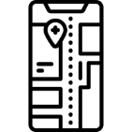 | - use maps, atlases, globes and digital/computer mapping to locate countries and describe features studied  - use the eight points of the compass, symbols, and keys to build knowledge of the areas studied.

Learning about London previously, helped me because__________________________________________________
________________________________________________________________________________________________Highlights: _______________________________________________________________________________________
________________________________________________________________________________________________

