

Year 3 Geography

Extreme Earth, Volcanoes and Earthquakes

Outcome –Deliver a news report describing a natural disaster and the impact on the communities affected.

Outcome: to create a quiz asking and answering questions about the UK, continents and oceans.

Prior knowledge and skills
 | - Identify the location of hot and cold areas of the world in relation to the Equator and the North and South Poles.
- Name, locate and identify the characteristics of the four countries and capital cities in the UK and surrounding seas.
- Name and locate the world’s seven continents and 5 oceans
 | - Use world maps, atlases and globes to identify the United Kingdom and its countries, as well as the countries (Costa Rica, Spain, and any others that are important to the cohort), continents (all) and oceans (main) studied in KS1

Vocabulary:
Physical: volcanoes, earthquakes, aftershock, cone, conservative plate boundary, constructive plate boundary, continental plate, crater, crust, destructive plate boundary, effusive eruption, epicentre, eruption cloud, explosive eruption, focus, foreshock, geothermal energy, inner core, lava, magma, magma chamber, main event, mantle, oceanic plate, outer core, Richter scale, secondary vent, subduction zone, tectonic plates, Ring of Fire, seismometer.
- Human: damage, tourism, fertile soil, mining, views, energy source, prepare, money, renewable energy.

Ideas and inspiration
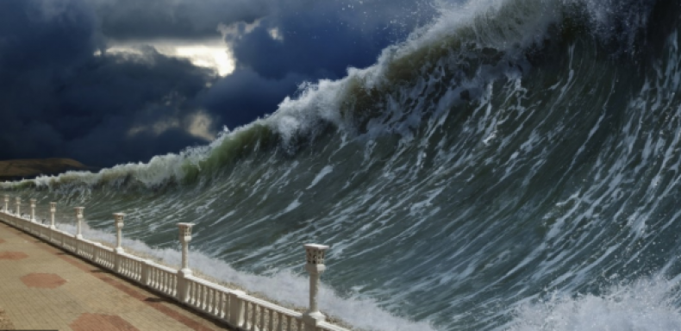

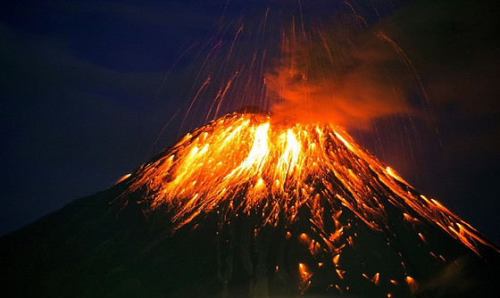

Using photos and pictures of volcanoes helped me because_____________________________________________
______________________________________________________________________________________________
Highlights: _____________________________________________________________________________________
______________________________________________________________________________________________
Developing Knowledge
Human and Physical features. |  | Working Towards | Within | Securely Within | Above
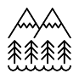   | - Explain how volcanoes are formed and how they affect people’s lives (Mt. Vesuvius).
 | - Identify different types of volcanoes: composite or strato, shield and dome.
 | - Explain what causes tsunamis and earthquakes, how earthquakes are measured and how they affect people’s lives (San Francisco).
 | - Explain the impact of natural disasters on humans.
Locational knowledge |  | Working Towards | Within | Securely Within | Above
 | - Locate countries of Europe (UK France, Germany, Italy, Greece, Portugal, Spain) using maps and locate volcanoes.
 | - Use a world map to identify physical characteristics, such as mountains, volcanoes as well as natural disasters including earthquakes and tsunamis.
Developing skills
Map skills |  | Working Towards | Within | Securely Within | Above
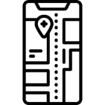 | - Use maps, atlases, globes and digital mapping to locate countries and describe features studied.
 | - Use four and six-figure grid references, symbols and keys to build their knowledge of the wider world.

