

Year 2

Geography- Monteverde Costa Rica
Outcome: To create a fact file on Costa Rica

Prior knowledge and skills
 | - Develop knowledge of their locality.
 | - Study the human and physical geography of a small area of the UK – Horley
 | - Use aerial photographs and plan perspectives to recognise landmarks and basic human and physical features in Horley including. Gatwick.
Vocabulary:
Continent: Asia, Africa, North America, South America, Antarctica, Europe and Australasia
Oceans: Pacific, Atlantic, Indian, Artic, Antarctic
Countries: UK, Costa Rica
Physical: climate, forests (cloud forest), hill, mountain, river, soil, vegetation, wildlife, weather
Human: attractions, farms, plantations (coffee, banana, pineapple), shops, tourism, settlements: towns, villages
General: equator, directional language (N,S,E,W)

Ideas and inspiration
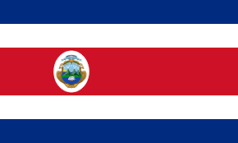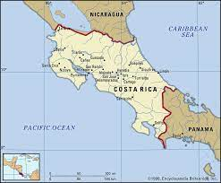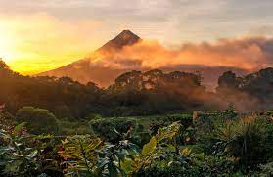

Developing Knowledge
Locational knowledge
 | - Name and locate the world’s seven continents and five oceans.
Place knowledge |  | Working Towards | Within | Securely Within | Above
 | - Understand geographical similarities and differences through studying the human and physical geography of a small area of the United Kingdom, and of a small area in a contrasting non-European country: Monteverde, Costa Rice vs Horley, UK
Human and physical geography |  | Working Towards | Within | Securely Within | Above
   | - Identify seasonal and daily weather patterns in the United Kingdom.
 | - Identify the location of hot and cold areas of the world in relation to the Equator and the North and South Poles (plotting UK and Costa Rica on the map and making links to the weather).
 | - Identify the seasonal and daily weather patterns in Costa Rica and compare this to the UK.
 | - Identify and compare key physical features of Horley and Monteverde including the landscape (forest, hill, mountain, river); soil; climate; vegetation and wildlife
 | - Identify and compare key human features of Horley and Monteverde including type of settlement (village/ town); farms; shops; and attractions
Developing skills
Map skills |  | Working Towards | Within | Securely Within | Above
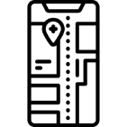 | - Use simple compass directions (north, south, east, and west) and locational and directional language to describe the location of features in Monteverde
 | - use world maps, atlases and globes to identify the United Kingdom and its countries, as well Costa Rica.
I would like to know more about __________________________________________________________________
______________________________________________________________________________________________
Highlights: _____________________________________________________________________________________
______________________________________________________________________________________________

