

Year 1 Geography- The UK, continents and oceans

Outcome: to create a quiz asking and answering questions about the UK, continents and oceans.

Prior knowledge and skills
 | - Visit local amenities observing landmarks on route.
 | - Use simple fieldwork and observational skills to study the geography of their school and its grounds.
 | - Use a simple map to locate Horley and compare to where other countries the children know are located.

Ideas and inspiration
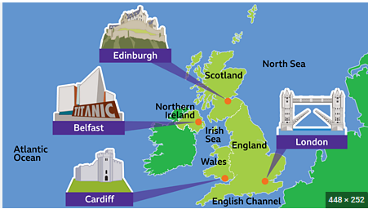

Vocabulary:
- United Kingdom
- London
- Cardiff
- Edinburgh
- Belfast
- North Sea
- Irish Sea
- Atlantic Ocean
- River
- Sea
- City

Developing Knowledge
Human and Physical features. |  | Working Towards | Within | Securely Within | Above
   | - Identify seasonal and daily weather patterns in the UK.  - Identify key physical and human features of each country of the UK.
Locational knowledge |  | Working Towards | Within | Securely Within | Above
 | - Name, locate and identify the characteristics of the four countries and capital cities in the UK and surrounding seas. (CGP guide pages 2-9)
Place knowledge |  | Working Towards | Within | Securely Within | Above
 | - Begin to name and locate the world’s seven continents and five oceans
Developing skills
Map skills |  | Working Towards | Within | Securely Within | Above
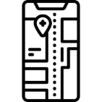 | - Use world maps, atlases and globes to identify the United Kingdom and its countries.
My map skills helped me because_________________________________________________________________

____________________________________________________________________________________________

Highlights: ___________________________________________________________________________________

____________________________________________________________________________________________

