

Reception

Geography - Around the world

Outcome: To draw and talk about life in Kenya Africa / polar region

Prior knowledge and skills
 | - Talk about what they see using a wide vocabulary.
 | - Know that there are different countries in the world and talk about the differences they have experienced or seen in photos.

Vocabulary:

Hot, cold, dry, wet, icy, desert, polar, landscape, traditional, farm, animals, mountains, rivers, forests, safari, water,

Ideas and inspiration
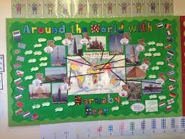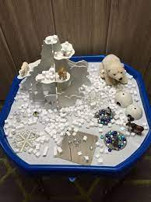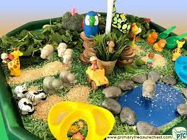

Human and Physical features. |  | Emerging | Expected
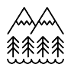   | - to observe the differences in weather from Horley, England to African, Kenya/Polar region.
 | - to recreate landmarks/places of interest in their play.
Locational knowledge |  | Emerging | Expected
 | - introduce and develop their knowledge of the local area (Horley)
 | - discuss what features /landmarks the children know
Place Knowledge |  | Emerging | Expected
 | - to say what is similar and different between where they live and Kenya/polar region
Map skills |  | Emerging | Expected
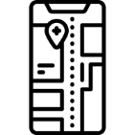 | - Use a simple map to locate Horley and compare to where other countries the children know are located.
Field work |  | Emerging | Expected
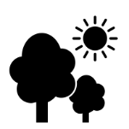 | - Use simple fieldwork and observational skills to study the geography of the school and its grounds.

