

Year 5

Geography- Protecting the planet
Outcome – To use Geographical knowledge to create ‘Top 10 tips’ to protect the planet.

Outcome: to create a quiz asking and answering questions about the UK, continents and oceans.

Prior knowledge and skills
 | - Use maps to locate some of the world’s rivers: the Severn, Danube, Colorado, Amazon
 | - Use fieldwork to observe, measure, record and present human and physical features in local area using a range of methods, including sketch maps, plans and graphs
 | - Describe and understand key aspects of a river system.

Vocabulary:
- Renewable energy
- Sources of energy:
Solar energy; combined cycle gas turbine (CCGT); nuclear; pumped storage; coal, wind
- sustainability
- turbine

Vocabulary:
- carbon footprint
- conserve
- consume
- export
- fertile land
- food miles
- import
- non-renewable energy
Sources of energy:
Solar energy; combined cycle gas turbine (CCGT), nuclear, pumped storage, coal.
turbine

Ideas and inspiration
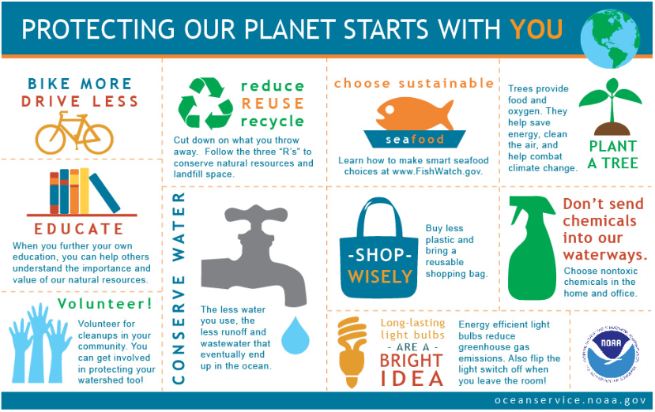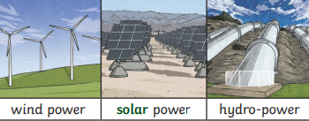

I used my learning in Science to help with Geography by______________________________________________
____________________________________________________________________________________________
Highlights: ___________________________________________________________________________________
____________________________________________________________________________________________
Developing Knowledge
Human and Physical features: |  | Working Towards | Within | Securely Within | Above
   | - Describe and understand key aspects of human geography in the context of what settlers need.
 | - Describe and understand key aspects of human geography in the context of renewable and non-renewable energy.
 | - Explain how and where electricity is generated and distributed within the UK.
 | - Compare natural resource supplies in the UK and abroad and understand how access varies in different countries.
 | - Explain where food comes from (food miles).
 | - Explore the importance of conserving food, water and energy supplies.
Locational knowledge |  | Working Towards | Within | Securely Within | Above
 | - To name and locate counties and cities of the United Kingdom, geographical regions and their identifying human and physical characteristics, key topographical features (including hills, mountains, coasts and rivers), and land-use patterns; and understand how some of these aspects have changed over time in the context of UK power stations.
Developing skills
Map skills |  | Working Towards | Within | Securely Within | Above
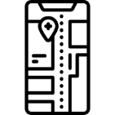 | - Identify UK power stations on a map.
 | - To use maps, atlases, globes and digital/computer mapping to locate countries and describe features in context of access to natural resources.
 | - Use digital maps to calculate food miles.

