

Year 2

Geography- Where we live - Transport.

Outcome: To describe a journey from Horley to a location in the UK or the wider world

Prior knowledge and skills
 | - Study the human and physical geography of a small area of the UK- Horley
 | - Label a simple map and use basic symbols in a key.
 | - Use aerial photographs and plan perspectives to recognise landmarks and basic human and physical features in Horley

Ideas and inspiration
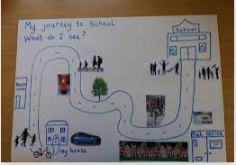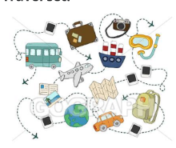

Vocabulary:

- station
- town
- transport
- rail line/ track
- route
- world links
Vocabulary:

- airport
- countries
- features
- fields
- journey
- mode of transport
- school
- sights

My map skills from Year 1 helped me because________________________________________________________
______________________________________________________________________________________________
Highlights: _____________________________________________________________________________________
______________________________________________________________________________________________
Developing Knowledge
Human and Physical features. |  | Working Towards | Within | Securely Within | Above
   | - To identify key human and physical features around the local area – airport, station, rail line fields, farms, towns, schools.
Locational knowledge |  | Working Towards | Within | Securely Within | Above
 | - To locate Horley on a map and describe what features they can see.
 | - To understand how Horley is linked to other places in the UK and the wider world.
Place Knowledge
 | - Name, locate and identify the characteristics of the 4 countries and capital cities in the UK in relation to Horley and discuss how you would travel there.
 | - To know that Horley is linked to other places within the UK and wider world via transport links. (These could include Spain, Costa Rica, Argentina, other places linked to individual families).
 | - To explain how they travel to different locations and why.
Developing skills
Map skills |  | Working Towards | Within | Securely Within | Above
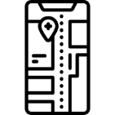 | - To use a key to identify transport links on map.
Field work |  | Working Towards | Within | Securely Within | Above
 | - To use directional language to (north, south, east & west) to describe the location of Horley in relation to London in the north, Brighton in the south.

