

Year 1

Geography- Where we live - Horley.

Outcome: To label a simple map of Horley using a basic key

Prior knowledge and skills
 | - Create a simple map of the school including features they have seen.
 | - Use simple fieldwork and observational skills to study the geography of the school and its grounds.
 | - Observe the human and physical geography of our school.

Vocabulary:
- Town
- river
- school
- Farm
- train station railway
- bridge
- subway
- church
- airport
- field
- hotel
- motorway

Ideas and inspiration
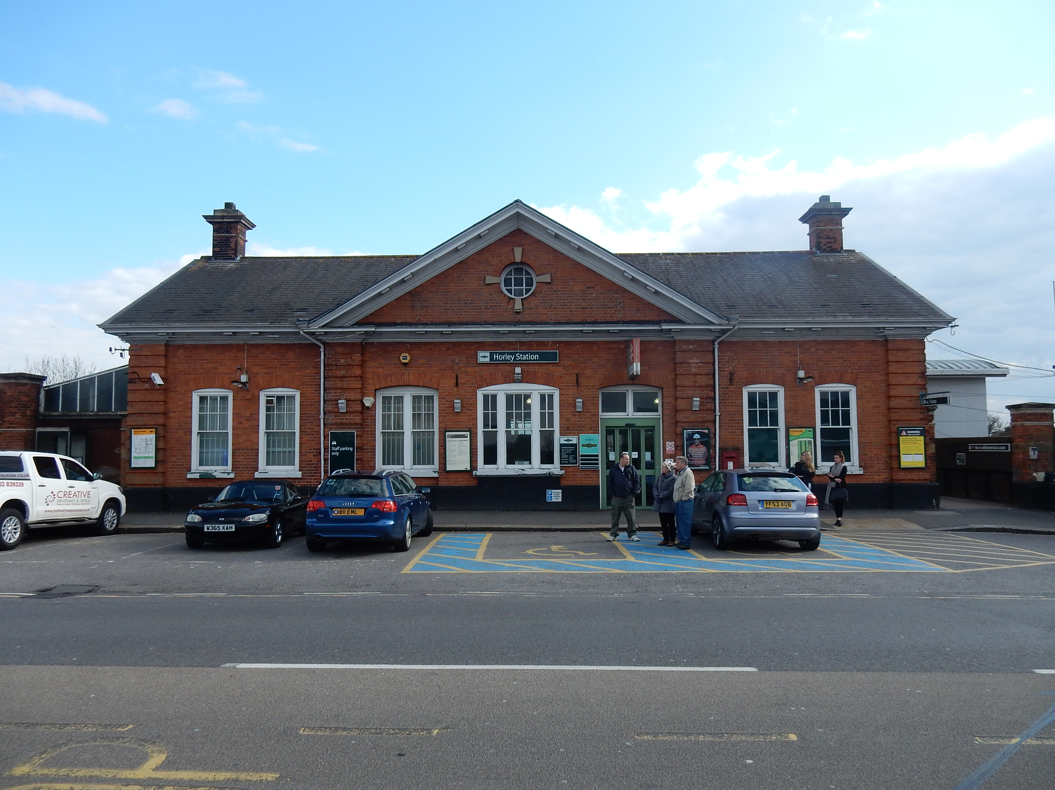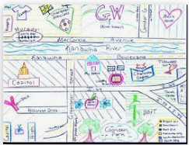

Developing Knowledge
Human and Physical features. |  | Working Towards | Within | Securely Within | Above
   | - To identify key landmarks in and around Horley Langshott School, Oakwood School, train station, shops, subway, church, library, supermarket, park, bridge
Locational knowledge |  | Working Towards | Within | Securely Within | Above
 | - To develop knowledge of their locality.
Place Knowledge
 | - To study the human and physical geography of a small area of the UK- Horley
Developing skills
Map skills |  | Working Towards | Within | Securely Within | Above
 | - Use aerial photographs and plan perspectives to recognise landmarks and basic human and physical features in Horley
 | - Labelling a simple map and use basic symbols in a key.
Field work |  | Working Towards | Within | Securely Within | Above
 | - To use their map to aid their visit to Horley.
I also use maps when___________________________________________________________________________

____________________________________________________________________________________________

Highlights: ___________________________________________________________________________________

____________________________________________________________________________________________

