

Reception

Geography- Where we live and our school.

Outcome: To make a simple map of the school.

Prior knowledge and skills
 | - Talk about what they see using a wide vocabulary.
 | - Know that there are different countries in the world and talk about the differences they have experienced or seen in photos.

Vocabulary:
- buildings
- features
- field
- location
- map
- office
- places
- playground
- pond
- office
- school
- route

Ideas and inspiration
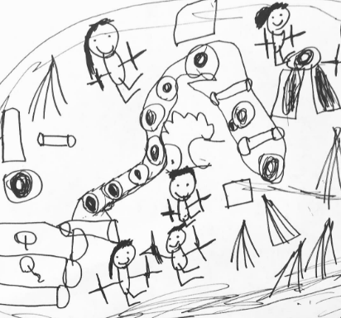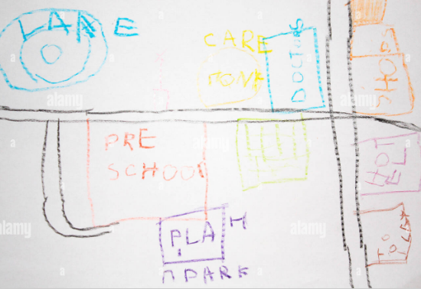

Human and Physical features. |  | Emerging | Expected
   | - Recreate landmarks/places of interest at Langshott School in their play.
Locational knowledge |  | Emerging | Expected
 | - Introduce and develop their knowledge of the school grounds – Woodlands, Forest Schools, field, KS2 building.
Place Knowledge |  | Emerging | Expected
 | - Observe the human and physical geography of our school.
Map skills |  | Emerging | Expected
 | - Talk about where we might use maps and look at different types.
 | - Create a simple map of the school including features they have seen.
Field work |  | Emerging | Expected
 | - Use simple fieldwork and observational skills to study the geography of the school and its grounds.
My favourite place in my school is:

_______________________________________________________________________

