

Year 6

Geography- Where we live – Settling in Horley

Outcome: To make, draw and describe how to improve Horley

Prior knowledge and skills
 | - Describe and understand different biomes and vegetation belts including aquatic, desert, forest (coniferous forest – taiga, temperate deciduous forest) tropical rainforest, grassland (savanna), tundra.
 | - Identify patterns of historical settlements – groups or lines of markers on maps
 | - Name and locate counties and cities of the United Kingdom geographical regions and their identifying human and physical characteristics, key topographical features, and land-use patterns; and understand how some of these aspects have changed over time.

Vocabulary:
- settlement
- improvement
- transport
- pedestrians
- location
- amenities
- topography
- development
- trade link
- land use
- environment
Ideas and inspiration
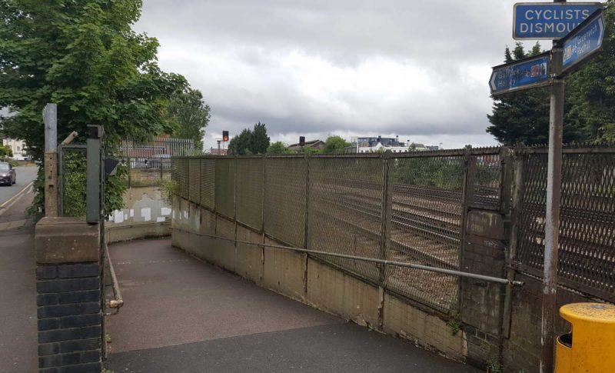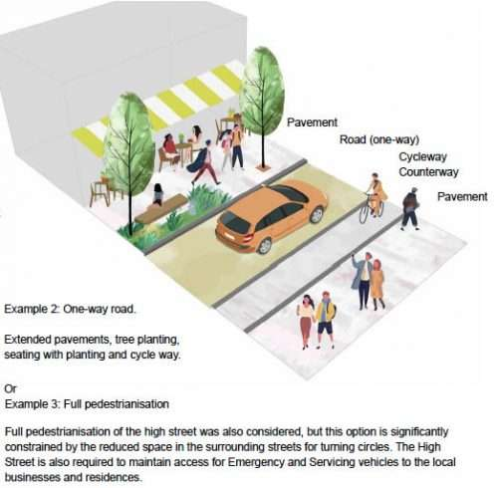

Developing Knowledge
Human and physical features. |  | Working Towards | Within | Securely Within | Above
   | - Explore which biome/vegetation belt Horley is within.
 | - Identify the type of settlement Horley is exploring the land use, and trade link.
 | - Give reasons why a settlement might be unsuitable.
Locational knowledge |  | Working Towards | Within | Securely Within | Above
 | - Locate Horley on a map and identify topographical features around the area (hills, rivers, fields, roads).
Place knowledge
 | - Explain why settlements develop in certain locations (where would you settle and why?).
 | - Explain what key features a settlement needs.
Developing skills
Map skills |  | Working Towards | Within | Securely Within | Above
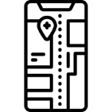 | - List the important features of a settlement site.
 | - Design and draw a new Horley – including a key for certain features – Police Station, Doctors, transport.
Fieldwork |  | Working Towards | Within | Securely Within | Above
 | - Use fieldwork to observe, measure, record and present the human and physical features in the local area – including sketch maps, plans and graphs.
 | - Use the eight points of the compass, six-figure grid references, symbols, and keys to build knowledge of the areas studied.
How did my prior learning help me?_____________________________________________________________________ __________________________________________________________________________________________________
Highlights: __________________________________________________________________________________________
____________________________________________________________________________________________________

