

Year 5 Geography

Comparing places: London and Barcelona
Outcome – To use our Geographical knowledge to create a double page spread comparing London and Barcelona.

Outcome: to create a quiz asking and answering questions about the UK, continents and oceans.

Prior knowledge and skills
 | - Use maps to locate some of the world’s rivers: the Severn, Danube, Colorado, Amazon
 | - Use fieldwork to observe, measure, record and present human and physical features in local area using a range of methods, including sketch maps, plans and graphs
 | - Describe and understand key aspects of a river system.

Vocabulary:
- climate: Maritime
- climate: Mediterranean
- economic opportunity
- global financial hub
- immigration
- layout
- migration
- population
- transportation
- tourism

Ideas and inspiration
Map of London Map of Barcelona

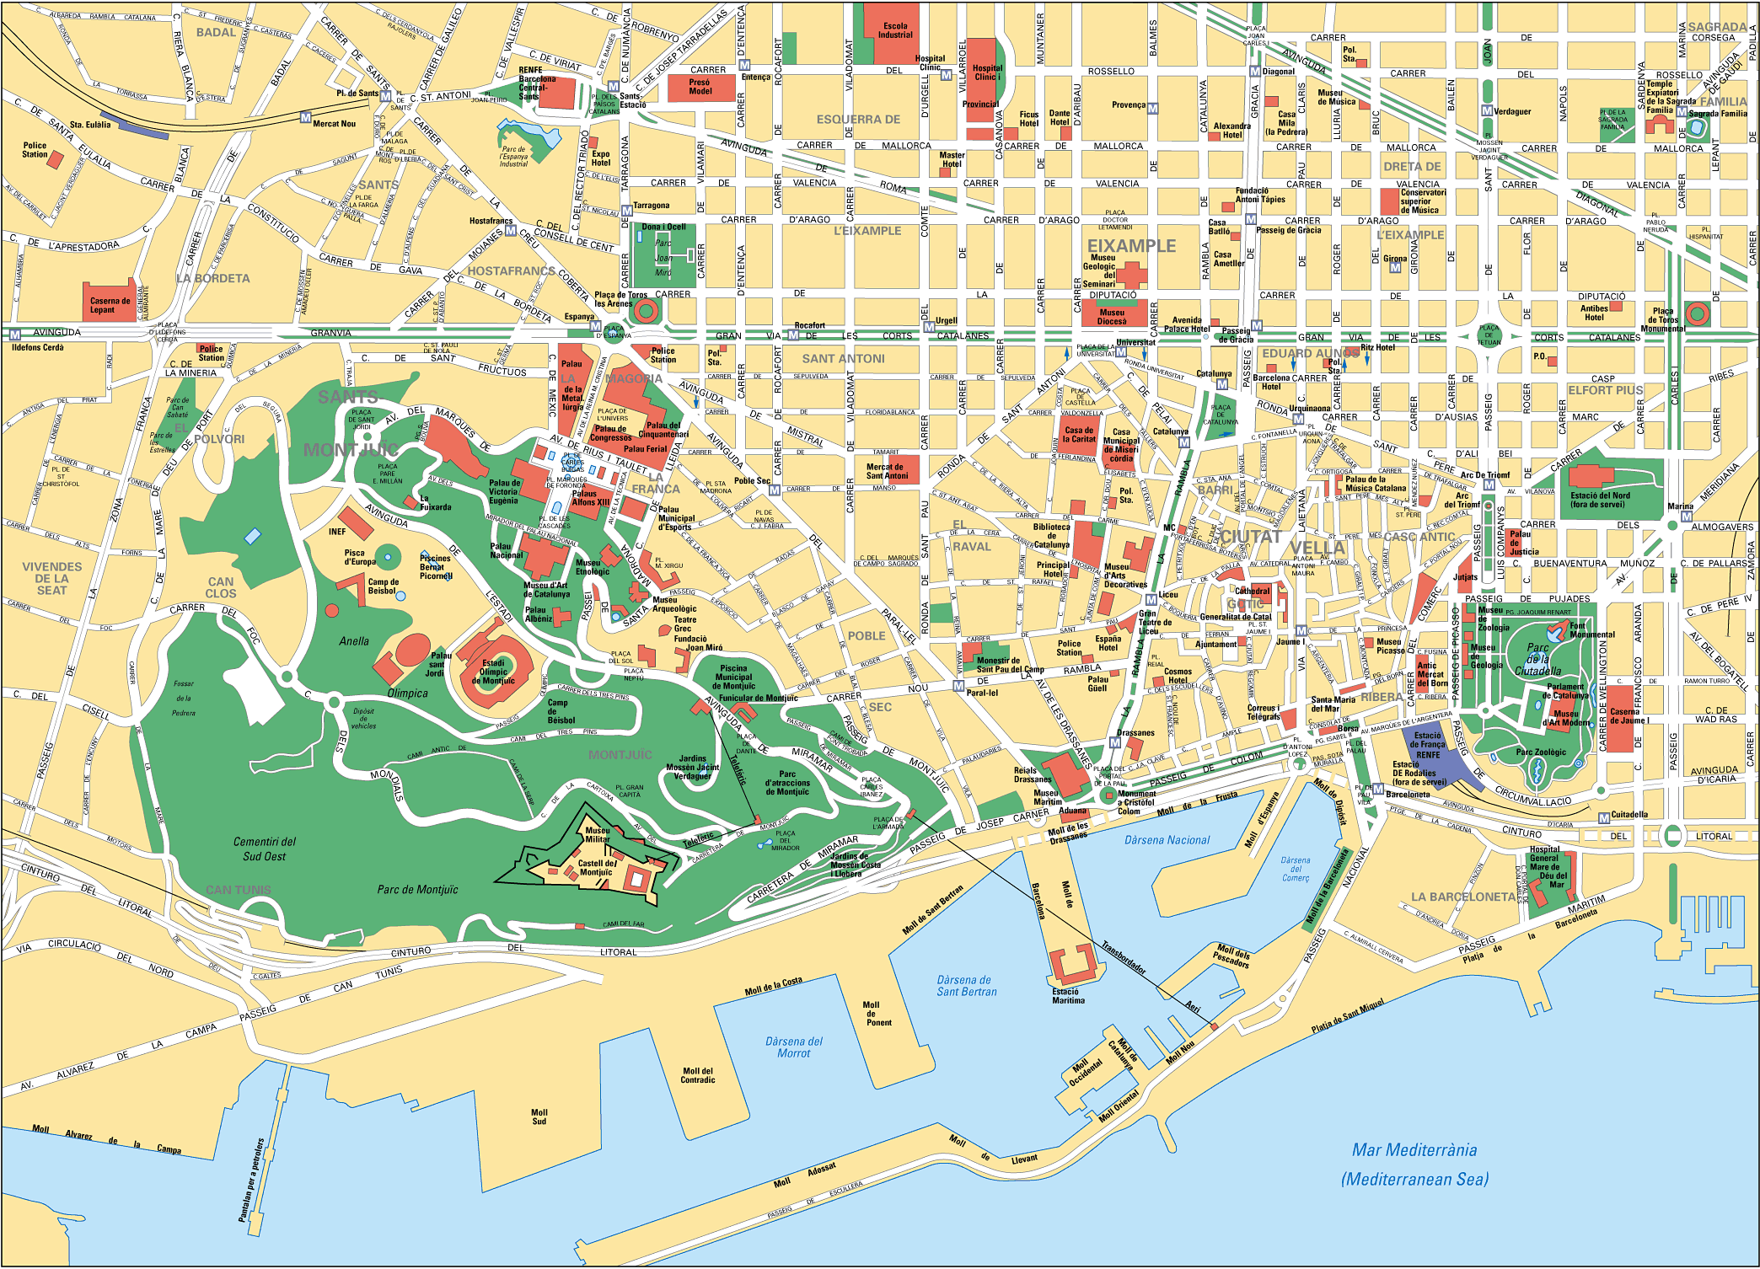
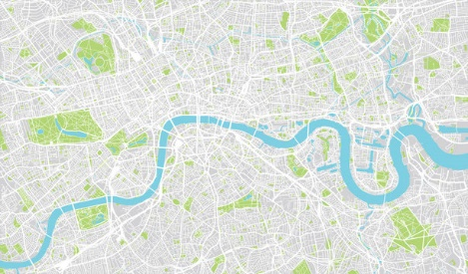

Developing Knowledge
Human and Physical features. |  | Working Towards | Within | Securely Within | Above
   | - Compare the physical features of London and Barcelona.  Focus: Barcelona – Montjuic Hill, Mediterranean coastline, River Besos, the Llobregat river; London – Thames river, flat terrain.
- Compare the human features of London and Barcelona.
Focus: Barcelona – La Sagrada Familiar, Park Guell, Las Rambla, Barcelona Metro, Camp Nou; London – Parliament, Tower bridge, The shard, London Underground, Wembley.
 | - Compare and contrast tourism and impact of tourism on London and Barcelona.
Locational knowledge |  | Working Towards | Within | Securely Within | Above
 | - Locate London and Barcelona on a map and concentrate on environmental regions, key physical and human characteristics.
 | - Identify the position and significance of latitude, longitude, Northern and Southern Hemisphere and use this to investigate climate and weather in London and Barcelona.
Place knowledge |  | Working Towards | Within | Securely Within | Above
 | - Understand geographical similarities and differences through a study of human features: transportation, food, population.
 | - Understand geographical similarities and differences through a study of physical features: climate.
Developing skills
Map skills |  | Working Towards | Within | Securely Within | Above
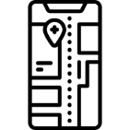 | - Use maps, atlases, globes and digital mapping to locate London and Barcelona.
 | - Use the eight points of the compass, symbols, and keys to build knowledge of the two areas studied.
My learning in Spanish has helped me in Geography because_________________________________________________
__________________________________________________________________________________________________Highlights: _________________________________________________________________________________________
__________________________________________________________________________________________________

