

Year 4

Geography- Where we live – our natural Earth

Outcome – To investigate the local ecosystem, identifying key features.

Outcome: to create a quiz asking and answering questions about the UK, continents and oceans.

Prior knowledge and skills
 | - Locate countries of Europe (UK France, Germany, Italy, Greece, Portugal, Spain) using maps. -use a world map to Identify physical characteristics: mountains, volcanoes/ earthquakes(Italy)
 | - Explain how volcanoes are formed and how they affect people’s lives (mt. Vesuvius)
- Use maps, atlases, globes and digital mapping to locate countries and describe features studied.
- Use four and six-figure grid references, symbols and keys to build their knowledge of the wider world.

Vocabulary:
- adapt
- alpine
- biomes
- climate
- coniferous
- deciduous
- desert
- ecosystem
- polar
- tropical
- vegetation
- vegetation belt

Ideas and inspiration
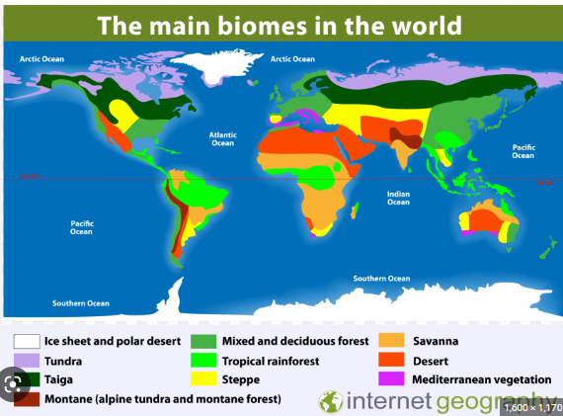

Developing Knowledge
Human and Physical features. |  | Working Towards | Within | Securely Within | Above
   | - Describe and understand different biomes and vegetation belts including aquatic, desert, forest (coniferous forest – taiga, temperate deciduous forest) tropical rainforest, grassland (savanna), tundra.
 | - Identify biomes and ecosystems found in the UK.
 | - Understand the impact of humans on chosen biome.
Locational knowledge |  | Working Towards | Within | Securely Within | Above
 | - Use a world map to locate countries around the world, concentrating on their environmental regions (biomes and vegetation belts).
 | - Identify the position and significance of latitude, longitude, Equator, Northern Hemisphere, Southern Hemisphere, the Tropics of Cancer and Capricorn, Arctic and Antarctic Circle in context of chosen biome.
Developing skills
Map skills and fieldwork |  | Working Towards | Within | Securely Within | Above
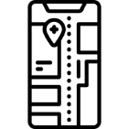  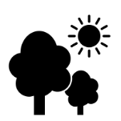 | - Use maps, atlases to locate countries and describe features.
 | - Locate different biome areas on a world map.
 | - Collect and analyse data from the local ecosystem (Forest School area).
Highlights: ____________________________________________________________________________________
_____________________________________________________________________________________________

