

Year 3

Geography- Where we live – How is land used?

Outcome: To sketch and describe the different land use in Horley

Prior knowledge and skills
 | - Understand how Horley is linked to other places in the UK and the wider world
 | - Name, locate and identify the characteristics of the 4 countries and capital cities in the UK in relation to Horley and discuss how you would travel there.
 | - Use directional language to describe the location of Horley in relation to London and Brighton.

Ideas and inspiration
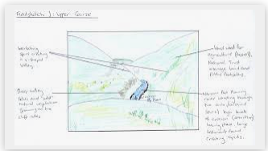

Vocabulary:
- Settlement
- Land use
- Airport
- Transport
- Development
- Location
- Farm land
- Housing
- Church
- Urban
- Rural

My map skills from Year 2 helped me because___________________________________________________________
________________________________________________________________________________________________
Highlights: _______________________________________________________________________________________
______________________________________________________________________________________________
Developing Knowledge
Human and Physical features. |  | Working Towards | Within | Securely Within | Above
   | - To identify and explain the land use within Horley and why.
 | - To describe how the human geography has changed.
Locational knowledge |  | Working Towards | Within | Securely Within | Above
 | - Locate Horley on a map and identify land-use patterns and understand how some of these aspects have changed over time.
 | - Compare how Horley/Gatwick land use has changed over time – before Acres and Westvale were built.
Place Knowledge
 | - To know what a settlement is.
 | - To explain why settlements develop in certain locations (London jobs, Victorian holidays).
 | - To identify similarities and differences between land use in different areas of Horley.
 | - To know the name of the county they are in and neighbouring counties – Surrey, Sussex, Kent, Greater London, Hampshire, Essex, Berkshire.
Developing skills
Map skills |  | Working Towards | Within | Securely Within | Above
 | - Recognise land use on maps.
Field work |  | Working Towards | Within | Securely Within | Above
 | - Sketch different areas of Horley to compare land use.

