
Langshott Computing Curriculum Map

2025-2026

A high-quality computing education equips pupils to use computational thinking and creativity to understand and change the world. Computing has deep links with mathematics, science, and design and technology, and provides insights into both natural and artificial systems. The core of computing is computer science, in which pupils are taught the principles of information and computation, how digital systems work, and how to put this knowledge to use through programming. Building on this knowledge and understanding, pupils are equipped to use information technology to create programs, systems and a range of content. Computing also ensures that pupils become digitally literate – able to use, and express themselves and develop their ideas through, information and communication technology – at a level suitable for the future workplace and as active participants in a digital world.

The national curriculum for computing aims to ensure that all pupils:
- can understand and apply the fundamental principles and concepts of computer science, including abstraction, logic, algorithms and data representation
- can analyse problems in computational terms, and have repeated practical experience of writing computer programs in order to solve such problems
- can evaluate and apply information technology, including new or unfamiliar technologies, analytically to solve problems
- are responsible, competent, confident and creative users of information and communication technology.
Key stage 1
- understand what algorithms are; how they are implemented as programs on digital devices; and that programs execute by following precise and unambiguous instructions
- create and debug simple programs
- use logical reasoning to predict the behaviour of simple programs
- use technology purposefully to create, organise, store, manipulate and retrieve digital content
- recognise common uses of information technology beyond school
- use technology safely and respectfully, keeping personal information private; identify where to go for help and support when they have concerns about content or contact on the internet or other online technologies.
Key stage 2
- design, write and debug programs that accomplish specific goals, including controlling or simulating physical systems; solve problems by decomposing them into smaller parts
- use sequence, selection, and repetition in programs; work with variables and various forms of input and output
- use logical reasoning to explain how some simple algorithms work and to detect and correct errors in algorithms and programs
- understand computer networks including the internet; how they can provide multiple services, such as the world wide web; and the opportunities they offer for communication and collaboration
- use search technologies effectively, appreciate how results are selected and ranked, and be discerning in evaluating digital content
- select, use and combine a variety of software (including internet services) on a range of digital devices to design and create a range of programs, systems and content that accomplish given goals, including collecting, analysing, evaluating and presenting data and information
- use technology safely, respectfully and responsibly; recognise acceptable/unacceptable behaviour; identify a range of ways to report concerns about content and contact.
 | R | 1 | 2 | 3 | 4 | 5 | 6
Coding and programming | Design, write and debug programs that accomplish specific goals.  Use sequence, selection, and repetition in programs; work with variables and various forms of input and output.  Use logical reasoning to explain how some simple algorithms work and to detect and correct errors in algorithms and programs.
Coding and programming | On the move | On the move | Different sorts of inputs | Sequence and animation | Introduction to variables | Speed direction and coordinates | More complex variable
Outcome | 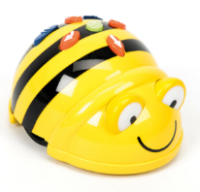 | Use clear instructions to create programs  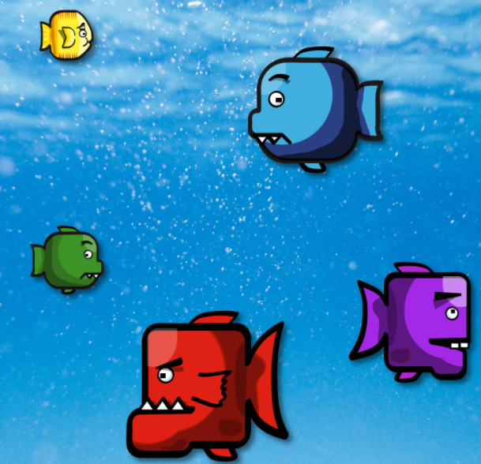 | use the keyboard to control objects on screen  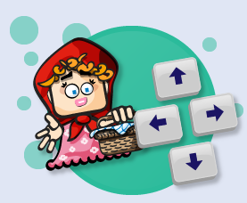 | Create simple animations and simulations   | Create simple programs using variables  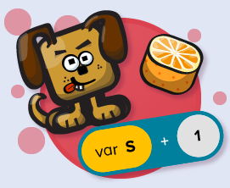 | Use numbers to represent actions  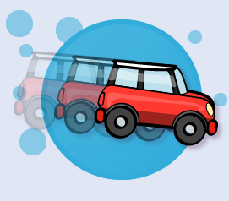 | Manipulate inputs to create useful outputs  
Debug   | Combine a sequence of directions to programme a bee bot or code – a – pillar. | To use code to write a computer program where objects in a space scene move when they are clicked on. | To write code that makes an object move around the screen when keys are pressed.  To write code that makes an object change direction when different keys on the keyboard are pressed. | To write code that uses a timer to create a sequence of traffic lights turning on and off.  . |  | To write code including if statements to make an object rotate, and combine this with conditional events to make a game. | To write code that prompts the user to input the value of a variable, and use this to create an  interactive block chart.  To write the code for a shopping till using variables to store and calculate values.
Sequence   | Use a sequence of directions to move the device around a story map. | To combine start events and click events to make a simple game.  To give instructions to make objects on the screen move when the program starts.  To combine start events and click events in code to make a magic castle. | To write code where different inputs can be used to make objects move and disappear.  To write code that makes an object change direction when the pointer is pressed and released. | To write a computer program where different pieces of code execute in a particular sequence.  To create a program that uses sequences for two different objects moving on the screen.  To write code that uses a timer to create a sequence of events | To use variables to keep track of the score in a game that uses conditional events.  To use a variable to keep track of the score in a game where the score increases, decreases or resets when different conditions are met.  To use a variable to keep track of the score in a game that uses conditional events.  To learn how to use multiple different variables and to set the value of a variable. | To use object properties (speed, heading and angle) to create a driving simulation.  To create a sailing game where a boat’s position on the screen is controlled by making changes to  its co-ordinates.  To set friction to affect the speed and movement of a car in a driving simulation. | To create a stopwatch with stop, start, and reset buttons, and both digital and analogue displays.
Logical reasoning   | Understand that the device is following the instructions we give it. |  | To make objects perform different actions when keys are pressed on the keyboard. |  | To understand how a variable can be used to keep track of the score in a game. | To understand that setting values in code to control the speed of an object. | To use my knowledge of variables to make a balloon pop game that gets harder as users score  more points.
Coding and programming |  | Simple inputs | Buttons and instructions | Conditional events | Repetition and loops | Random numbers and simulations | Object properties
Outcome |  | Combine input events to create apps and programs  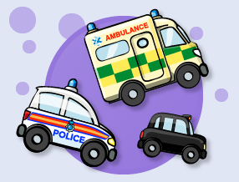 | Write codes to instruct objects  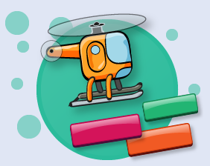 | Code with ‘if statements’ which select different pieces of code to execute depending on what happens to other objects  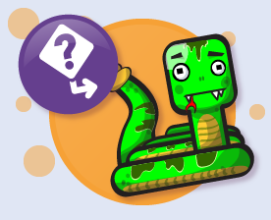 | When coding, use repetition and loops  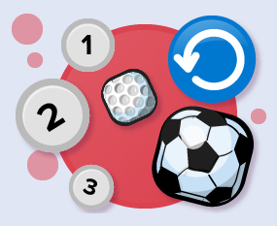 | Create inputs to generate random numbers  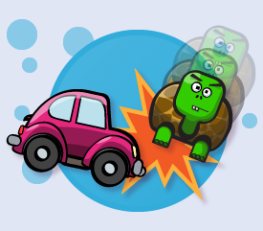 | Use property values and parameters to store information about objects  
Debug |  | To combine start events and click events to program cars and emergency vehicles in an animated traffic scene. | To write code where buttons can be used to make an object move around the screen. | To make a simple game that uses conditional hit events to check if one object has hit another.  To use conditional hit events to control the movement of a car on the screen. | To write the code to program a rocket to orbit round the spinning Moon, using the concepts of loops, regular or infinite repetition, and ‘if statement’ blocks.  To write code that uses nested loops to create a car-driving program. | To write code for a game that uses random numbers to move objects in different directions  To write code that uses random numbers to move objects at random speeds and headings, and  use this to create a game. | To write code that detects the properties of an object and passes the value of these properties (or  a set of parameters) to other objects, and to use this to create a space game.  To make a game that moves objects around by getting information from events and passing object  properties.
Sequence |  | To use code to make objects move when they are clicked on.  To combine start events and click events to make a simple game. | To write the code for a simple game where buttons are used to move an object around and cast magic ‘disappearing spell’.  To write the code for a simple game where buttons are used to move an object around | To use ‘hit events’ to program a space maze game in which an object reacts to particular conditions. | To use a loop to do something repeatedly in a program.  Designs simple algorithms using loops and selection, i.e. if statements. (AL)  To use loops, a variable and if statements to create an animated scene of hot air balloons  performing a repeating pattern in the sky. | To create a ping-pong game, using random headings in specific ranges.  To be able to generate and display random numbers, and use these within the program for a car racing game. | To create a golf game by writing code that accesses and uses object properties, including passing  the value of these properties to other objects (passing a set of parameters).  To create a game where players stop objects moving by changing their properties.  To make a football game that passes the speed and heading of the pointer’s movement to a ball  on the screen.
Logical reasoning |  | To understand that when a computer does something it is following instructions called ‘code’. |  | To program a simple game where conditional events are used to check whether objects have  collided. |  | To understand how numbers in combination with variables and conditional hit events to create a  realistic pinball game. | To learn how to pass properties from one object to a second in order to make the second object  move relative to the first.
 |  | Vocabulary  Code, instructions, screen, direction, left/right/up/down, run, action, object, click/clicked, scene, program, instructions, algorithm, click, code icon, start, block, icon, start event, click event | Vocabulary  Key pressed, event, object, action, program, characters, control, action, algorithm, run, execute, direction, code, event box, key press, button, click, fix, bug, debugging, instructions, icon, design, start, app, save, share, code | Vocabulary  Algorithm, instructions, commands, forward (fd), left (lt), move, turn, clear screen (cs), variable, repeat, sprite, block, green flag, change colour, key press, code | Vocabulary  Sprite, block, command, background, backdrop, algorithm, move, turn, green flag, key press, pen, repeat, code | Vocabulary  Animate, animation, project, remix, repeat, iteration, debug, broadcast, receive, sequence, show, hide, visible, invisible, deconstruct, transition, audio, record, interactive, user | Vocabulary  Algorithm, sprite, backdrop, background, script, block, events, sequence, gradient, fill, levels, repeat, commentary, consequence, action, penalty, debug, costume, code
Online Safety | Learn how to use technology safely and respectfully, keeping personal information private; identify where to go for help and support when they have concerns about content or contact on the internet or other online technologies.
Outcome | To know how to keep myself safe online.  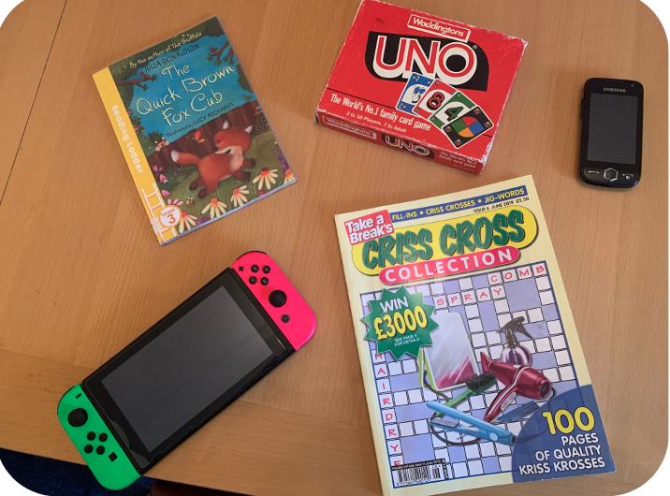 | To know how to keep myself safe online.   | 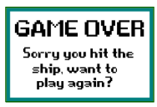  To know how to keep myself safe online. |   To know how to keep myself and others safe online. | To demonstrate how to keep myself and others safe online.  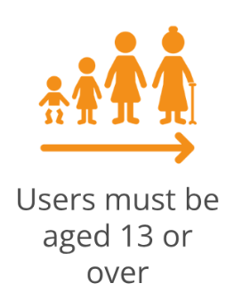 | To demonstrate how to keep myself and others safe online and apply this to my online interactions in the real world.  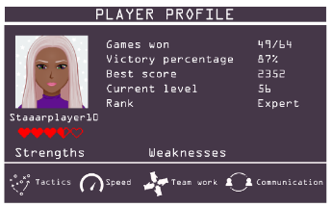 | 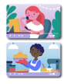  To demonstrate how to keep myself and others safe online and apply this to my online interactions in the real world.
Self-image and identity   | I can recognise, online or offline, that anyone can say ‘no’ - ‘please stop’ - ‘I’ll tell’ - ‘I’ll ask’ to somebody who makes them feel sad, uncomfortable, embarrassed or upset. | I can recognise that there may be people online who could make someone feel sad, embarrassed or upset. If something happens that makes me feel sad, worried, uncomfortable or frightened, I can give examples of when and how to speak to an adult I can trust and how they can help. | I can explain how other people may look and act differently online and offline.  I can give examples of issues online that might make someone feel sad, worried, uncomfortable or frightened; I can give examples of how they might get help. | I can explain what is meant by the term ‘identity’. I can explain ways in which someone might change their identity depending on what they are doing online (e.g. gaming; using an avatar; social media) and why. | I can explain how my online identity can be different to my offline identity.  I can describe positive ways for someone to interact with others online and understand how this will positively impact on how others perceive them.  I can explain that others online can pretend to be someone else, including my friends, and can suggest reasons why they might do this. | I can explain how identity online can be copied, modified or altered.  I can demonstrate how to make responsible choices about having an online identity, depending on context. | I can identify and critically evaluate online content relating to gender, race, religion, disability, culture and other groups, and explain why it is important to challenge and reject inappropriate representations online.  I can describe issues online that could make anyone feel sad, worried, uncomfortable or frightened. I know and can give examples of how to get help, both on and offline. I can explain the importance of asking until I get the help needed.
Online relationships   | I can recognise some ways in which the internet can be used to communicate.  I can give examples of how I (might) use technology to communicate with people I know. | I can give examples of when I should ask permission to do something online and explain why this is important. | I can describe different ways to ask for, give, or deny my permission online and can identify who can help me if I am not sure.  I can explain why I have a right to say ‘no’ or ‘I will have to ask someone’. I can explain who can help me if I feel under pressure to agree to something I am unsure about or don’t want to do. | I can explain what it means to ‘know someone’ online and why this might be different from knowing someone offline.  I can explain why someone may change their mind about trusting anyone with something if they feel nervous, uncomfortable or worried. | I can give examples of how to be respectful to others online and describe how to recognise healthy and unhealthy online behaviours.  I can explain how content shared online may feel unimportant to one person but may be important to other people’s thoughts feelings and beliefs. | I can explain that there are some people I communicate with online who may want to do me or my friends harm. I can recognise that this is not my / our fault.  I can describe some of the ways people may be involved in online communities and describe how they might collaborate constructively with others and make positive contributions. (e.g. gaming communities or social media groups). | . I can explain how sharing something online may have an impact either positively or negatively. I can describe how things shared privately online can have unintended consequences for others. e.g. screen-grabs.  I can explain that taking or sharing inappropriate images of someone (e.g. embarrassing images), even if they say it is okay, may have an impact for the sharer and others; and who can help if someone is worried about this.
Online reputation   | I can identify ways that I can put information on the internet. | I can describe what information I should not put online without asking a trusted adult first. | I can explain how information put online about someone can last for a long time.  I can describe how anyone’s online information could be seen by others. | I can explain how to search for information about others online.  I can explain the need to be careful before sharing anything personal. | I can describe how to find out information about others by searching online.  I can explain ways that some of the information about anyone online could have been created, copied or shared by others. | I can search for information about an individual online and summarise the information found. I can describe ways that information about anyone online can be used by others to make judgments about an individual and why these may be incorrect. | I can explain the ways in which anyone can develop a positive online reputation.  I can explain strategies anyone can use to protect their ‘digital personality’ and online reputation, including degrees of anonymity.
Online bullying   | I can describe ways that some people can be unkind online.  I can offer examples of how this can make others feel. | I can describe how to behave online in ways that do not upset others and can give examples. | I can explain what bullying is, how people may bully others and how bullying can make someone feel.  I can talk about how anyone experiencing bullying can get help. | I can describe appropriate ways to behave towards other people online and why this is important.  I can give examples of how bullying behaviour could appear online and how someone can get support. | I can recognise when someone is upset, hurt or angry online.  I can explain why people need to think carefully about how content they post might affect others, their feelings and how it may affect how others feel about them (their reputation). | I can explain how anyone can get help if they are being bullied online and identify when to tell a trusted adult.  I can identify a range of ways to report concerns and access support both in school and at home about online bullying.  I can describe the helpline services which can help people experiencing bullying, and how to access them (e.g. Childline or The Mix). | I can describe how to capture bullying content as evidence (e.g screen-grab, URL, profile) to share with others who can help me.  I can explain how someone would report online bullying in different contexts.
Managing online information   | I can talk about how to use the internet as a way of finding information online.  I can identify devices I could use to access information on the internet. | I know / understand that we can encounter a range of things online including things we like and do not like as well as things which are real or make believe / a joke.  I know how to get help from a trusted adult if we see content that makes us feel sad, uncomfortable, worried or frightened.. | I can explain what voice activated searching is and how it might be used, and know it is not a real person (e.g. Alexa, Google Now, Siri). I can explain the difference between things that are imaginary, ‘made up’ or ‘make believe’ and things that are ‘true’ or ‘real’. I can explain why some information I find online may not be real or true. | I can demonstrate how to use key phrases in search engines to gather accurate information online.  I can explain the difference between a ‘belief’, an ‘opinion’ and a ‘fact. and can give examples of how and where they might be shared online, e.g. in videos, memes, posts, news stories etc. | I can analyse information to make a judgement about probable accuracy and I understand why it is important to make my own decisions regarding content and that my decisions are respected by others.  I can explain why lots of people sharing the same opinions or beliefs online do not make those opinions or beliefs true.  I can explain that technology can be designed to act like or impersonate living things (e.g. bots) and describe what the benefits and the risks might be. | I can explain what is meant by ‘being sceptical’; I can give examples of when and why it is important to be ‘sceptical’.  I can evaluate digital content and can explain how to make choices about what is trustworthy e.g. differentiating between adverts and search results.  I can explain key concepts including: information, reviews, fact, opinion, belief, validity, reliability and evidence.  . | I can describe how some online information can be opinion and can offer examples. I can explain how and why some people may present ‘opinions’ as ‘facts’; why the popularity of an opinion or the personalities of those promoting it does not necessarily make it true, fair or perhaps even legal. I can define the terms ‘influence’, ‘manipulation’ and ‘persuasion’ and explain how someone might encounter these online (e.g. advertising and ‘ad targeting’ and targeting for fake news).
Health, well-being and lifestyle   | I can identify rules that help keep us safe and healthy in and beyond the home when using technology and I can give some simple examples of these rules. | I can explain rules to keep myself safe when using technology both in and beyond the home. | I can explain simple guidance for using technology in different environments and settings e.g. accessing online technologies in public places and the home environment.  I can say how those rules / guides can help anyone accessing online technologies. | I can explain why spending too much time using technology can sometimes have a negative impact on anyone.  I can explain why some online activities have age restrictions, why it is important to follow them and know who I can talk to if others pressure me to watch or do something online that makes me feel uncomfortable (e.g. age restricted gaming or web sites). | I can explain how using technology can be a distraction from other things, in both a positive and negative way.  I can identify times or situations when someone may need to limit the amount of time they use technology e.g. I can suggest strategies to help with limiting this time. | I can describe some strategies, tips or advice to promote health and wellbeing with regards to technology.  I recognise the benefits and risks of accessing information about health and well-being online and how we should balance this with talking to trusted adults and professionals. | I can describe common systems that regulate age-related content (e.g. PEGI, BBFC, parental warnings) and describe their purpose.  I can assess and action different strategies to limit the impact of technology on health (e.g. night-shift mode, regular breaks, correct posture, sleep, diet and exercise).
Privacy and security   | I can identify some simple examples of my personal information (e.g. name, address, birthday, age, location) and describe who would be trustworthy to share this information with; I can explain why they are trusted. | I can recognise more detailed examples of information that is personal to someone (e.g where someone lives and goes to school, family names).  I can explain why it is important to always ask a trusted adult before sharing any personal information online, belonging to myself or others. | I can explain how passwords can be used to protect information, accounts and devices.  I can explain and give examples of what is meant by ‘private’ and ‘keeping things private’. I can describe and explain some rules for keeping personal information private (e.g. creating and protecting passwords). | I can describe simple strategies for creating and keeping passwords private.  I can give reasons why someone should only share information with people they choose to and can trust. I can explain that if they are not sure or feel pressured then they should tell a trusted adult. | I can explain that internet use is never fully private and is monitored, e.g. adult supervision.  I can describe how some online services may seek consent to store information about me; I know how to respond appropriately and who I can ask if I am not sure.  I know what the digital age of consent is and the impact this has on online services asking for consent. | I can explain how many free apps or services may read and share private information (e.g. friends, contacts, likes, images, videos, voice, messages, geolocation) with others.  I can explain what app permissions are and can give some examples. | I can describe simple ways to increase privacy on apps and services that provide privacy settings.  I can describe ways in which some online content targets people to gain money or information illegally; I can describe strategies to help me identify such content (e.g. scams, phishing).
Copyright and ownership   | I know that work I create belongs to me and that I can name my work so that others know it belongs to me. | I can say why it belongs to me (e.g. ‘I designed it’ or ‘I filmed it’’) | I can recognise that content on the internet may belong to other people. I can describe why other people’s work belongs to them. | I can explain why copying someone else’s work from the internet without permission isn’t fair and can explain what problems this might cause. | When searching on the internet for content to use, I can explain why I need to consider who owns it and whether I have the right to reuse it.  I can give some simple examples of content which I must not use without permission from the owner, e.g. videos, music, images. | I can assess and justify when it is acceptable to use the work of others.  I can give examples of content that is permitted to be reused and know how this content can be found online. | I can demonstrate the use of search tools to find and access online content which can be reused by others. I can demonstrate how to make references to and acknowledge sources I have used from the internet.

