

RE – Islam: What helps Muslims to live a good life? (Year 6)
Outcome: Create a presentation about what helps Muslims live a good life.

Prior Knowledge and Skills
 | - Islam is one of the major world religions

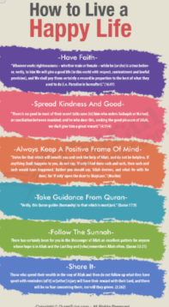
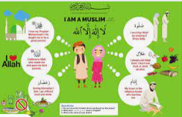
Vocabulary:
- Eternal
- Omniscient
- Omnipotent
- Qur’an
- Allah
- Pillars
- Pray
- Alms
- fast

Ideas and inspiration:

https://www.bbc.co.uk/programmes/b05pc1c9/clips

Developing Knowledge
Islam |  |  | Working Towards | Within | Securely Within | Above
 |  | - To know that Islam is a monotheistic religion.
 |  | - To know that a believer can approach Allah by praying, and by reciting the Qur'an
 |  | - To know what the pillars (or duties) of Islam are and how they help many Muslims to have a good life
 |  | - To know that Allah is eternal, omniscient and omnipotent
 |  | - To know the purpose of the Two Angels, which are said to sit on either shoulder of a Muslim person
 |  | - To know the purpose of the Two Angels, which are said to sit on either shoulder of a Muslim person
Developing Skills
Engage |  |  | Working Towards | Within | Securely Within | Above
 |  | - To think about why Allah so important to Muslims and how this affects the way Muslims live
 |  | - To think about how the two angels affect the way Muslims live their lives
 |  | - To think about what motivates a Muslim to pray/ give alms/ fast
Enquire and explore |  |  | Working Towards | Within | Securely Within | Above
 |  | - To investigate connections between Islam and other religions they have studied
 |  | - To investigate some key beliefs about Allah, worship practices and the pillars and explain how they help to shape a good life for Muslims
Evaluate |  |  | Working Towards | Within | Securely Within | Above
 | - To reflect on why living a good life might be important to Muslims and how different people might answer this question (Thematic)
Express |  |  | Working Towards | Within | Securely Within | Above
 | - To express knowledge of what helps Muslims live a good life
Reflections: ____________________________________________________________________________________
_____________________________________________________________________________________________

