Prior Knowledge and Skills
 | - Buddhism is one of the World's largest religions.  - To know what worship looks like in some other religions including Christianity, Hinduism and Sikhism.


RE – Buddhism: What is the ‘Buddhist way of life’? (Year 5)
Outcome - Create a Tibetan prayer flag.

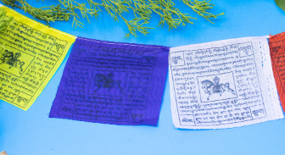
Vocabulary:
- Siddhartha Gautama
- Buddha
- enlightenment
- meditation
- shrine
- Nirvana
- Four Noble Truths
- Eightfold Path
- rebirth

Ideas and inspiration:

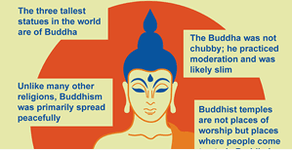

Developing Knowledge
Buddhism |  |  | Working Towards | Within |  | Securely Within |  |  | Above
 |  | - To know about the story of how Prince Siddhartha became Buddha.
 |  | - To know that ‘Buddha’ means ‘awakened’ or ‘enlightened one’.
 |  | - To know that Buddhists follow the teachings of Buddhism to gain enlightenment (Nirvana) which is achieved by meditating
 |  | - To know that there is no supreme deity in Buddhism
 |  | - To know that there are Four Noble Truths in Buddhism
 |  | - To know that Buddhists follow the teachings of the Eightfold Path
 |  | - To know that there are artefacts that help Buddhists to meditate
 |  | - To know that worship and meditation are different
Developing Skills
Engage |  |  | Working Towards | Within |  | Securely Within |  |  | Above
 |  | - To think about Buddhism beliefs and practices using images including pagodas, a Buddha statue, symbols, a monk, a map of India – make links.
Enquire and explore |  |  | Working Towards | Within |  | Securely Within |  |  | Above
 |  | - To investigate the story of Prince Siddhartha Gautama and find out what changed his life.
Evaluate |  |  | Working Towards | Within |  | Securely Within |  |  | Above
 | - To reflect on what it means to be “enlightened”. Compare this idea with the Christian idea of being “lights in the world.”
 | - To reflect on the similarities and differences between “worship,” “prayer” and “meditation”.
Express |  |  | Working Towards | Within |  | Securely Within |  |  | Above
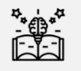 | - To express knowledge and understanding by creating a Tibetan prayer flag.
Reflections: ____________________________________________________________________________________
______________________________________________________________________________________________

