

RE- Hinduism: What does it mean to be a Hindu and how do they live a good life? (Year 4)
Outcome- Create a leaflet or poster showing how a Hindu person can live a good life

Outcome: To create a Parable quiz.

Prior Knowledge and Skills
 | - Know that Hinduism is a major world religion
 | - To think about how and why some festivals are celebrated
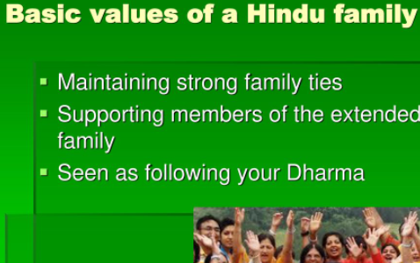
Vocabulary:
- Karma
- Dharma
- Sanatana
- Brahman
- duties
- Rama
- Sita
- samsara

Ideas and inspiration:

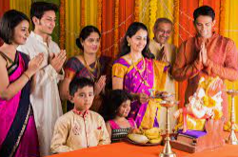

Developing Knowledge
Hinduism |  |  | Working Towards | Within | Securely Within | Above
 |  | - To know that the religion of Hindus is called ‘Sanatana Dharma’ (Eternal Truth)
 |  | - To know that most Hindus (Sanatanis) believe in only one Supreme Being – Brahman – and that every living thing has a spark of Brahman (atman) in it
 |  | - To know that many Hindus (Sanatanis) try to live good lives by doing ‘dharma’ (righteous duties)
 |  | - To know that worship (puja and arti) is a duty throughout life
 |  | - To know the story of Rama and Sita (the Ramayana) and what it teaches Hindus (Sanatanis) about dharma and how to live
Developing Skills
Engage |  |  | Working Towards | Within | Securely Within | Above
 |  | - To think about how dharma (duty) is presented in the story of Rama and Sita and/or how the couple are an example for Hindus
Enquire and explore |  |  | Working Towards | Within | Securely Within | Above
 |  | - To investigate what samsara is and what impact living a good life has on karma
Evaluate |  |  | Working Towards | Within | Securely Within | Above
 | - To reflect on how doing ‘dharma’ helps Hindus to live a good life
Express |  |  | Working Towards | Within | Securely Within | Above
 | - To express understanding by creating a leaflet or poster with information on how to live a good life as a Hindu.

Reflections: _______________________________________________________________________________
____________________________________________________________________________________________

Highlights: _______________________________________________________________________________________

_______________________________________________________________________________________________

