

RE- Sikhism: What do Sikhs value? (Year 3)
Outcome - Create a recipe for equality (a cup of pray and a pinch of respect)
What do Sikhs value?

Outcome –Create a recipe for equality (a cup of pray and a pinch of respect)

Outcome: To create a Parable quiz.

Prior Knowledge and Skills
 | - Know that Sikhism is a major World religion  - Know that some faiths have symbols which represent important elements

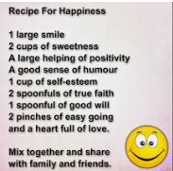
Ideas and inspiration:

Vocabulary:
- Guru
- Il Onkar (oneness of God)
- Naam
- equality
- Gurdwara
- Khanda
- Langar
- Five Ks

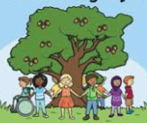
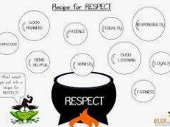

Developing Knowledge
Sikhism |  |  | Working Towards | Within | Securely Within | Above
 |  | - To know that Guru Nanak Ji* was the founder of Sikhism & that he is not worshipped as a god
 |  | - To know that Sikhs worship at home and at the Gurdwara
 |  | - To know that the Sikh holy book is called ‘Guru Granth Sahib Ji’
 |  | - To know that Sikhs have special symbols which reflect Sikh identity, including the Five Ks
 |  | - To know that equality is very important in Sikh society
 |  | - To know that ‘guru’ means ‘teacher’ and that there are ten gurus of Sikhism
 |  | - -To know that the three main duties of a Sikh are to ‘Pray, Work and Give’
Developing Skills
Engage |  |  | Working Towards | Within | Securely Within | Above
 |  | - To think about what groups you belong to. To bring in something that identifies you as part of a group
Enquire and explore |  |  | Working Towards | Within | Securely Within | Above
 |  | - To investigate the main beliefs and 5k’s
 |  | - To investigate that the three main duties of a Sikh are to ‘Pray, Work and Give’
 |  | - To investigate how Sikhs worship at home and at the Gurdwara
 |  | - To investigate the symbols of the Sikh faith
 |  | - To investigate how Sikh’s join the Kelsa
Evaluate |  |  | Working Towards | Within | Securely Within | Above
 | - To reflect on what Sikhs believe about equality and why this is important to their faith
Express |  |  | Working Towards | Within | Securely Within | Above
 | - To express knowledge of the Sikh faith and important factors by creating a recipe for equality
Reflections: _______________________________________________________________________________
____________________________________________________________________________________________

