

RE- Judaism: What is the Torah and why do Jewish families celebrate Shabbat? (Year 2)
Outcome- Create a scroll, writing some Hebrew letters or one of the commandments

Outcome: To retell a story from the Old Testament.

Prior Knowledge and Skills
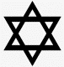 | - Know that Judaism is one of the major World religions.  - To know books that are special to people who have different religions and beliefs.  - The Bible contains many stories about God.

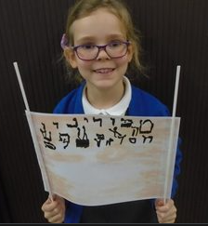
Ideas and inspiration:

Vocabulary:
- respect
- holy
- Torah
- scroll
- value / valuable
- precious
- synagogue
- Shabbat

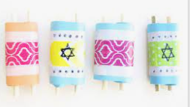

Developing Knowledge
Judaism |  |  | Working Towards | Within | Securely Within | Above
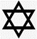 |  | - To know what it means to treat something with respect
 |  | - To know that the Torah is the Jewish holy book and contains rules for Jews to live by
 |  | - To know that the Torah is in the form of a scroll and is written in Hebrew
 |  | - To know that the Torah can also be found in the Old Testament section of the Bible
 |  | - To know that the synagogue is the place where Jews go to learn, worship God and is where the Torah is kept
 |  | - To know that Shabbat is a time of rest and is one of the commandments
 |  | - To know that Shabbat and the Friday night meal can be an important part of Jewish family life and can help Jewish families to feel closer to God
 |  | - To know that Shabbat is a time of rest and a commandment from the Torah
 |  | - To know that Shabbat and the Friday night meal can be an important part of Jewish family life and can help Jewish families to feel closer to God
Developing Skills
Engage |  |  | Working Towards | Within | Securely Within | Above
 |  | - To think about books that are special to us and explain why
 |  | - To think about why rest might be important.
Enquire and explore |  |  | Working Towards | Within | Securely Within | Above
 |  | - To investigate what makes the Torah special by looking at it being used in the Synagogue.
 |  | - To investigate how Jewish families put their beliefs into practice.
Evaluate |  |  | Working Towards | Within | Securely Within | Above
 | - To reflect on what makes the Torah so important to Jews and why Jews celebrate Shabbat.
Express |  |  | Working Towards | Within | Securely Within | Above
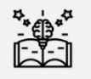 | - To express knowledge of the Torah by creating a scroll
Reflections: ____________________________________________________________________________________
______________________________________________________________________________________________

