

RE-Why should we look after our world? (Year 1)
Outcome: Create a ‘wonder-full’ collage’ of children’s pictures and images of what makes the world wonderful.

Prior Knowledge and Skills
 | - Know that our world is a place of wonder that some people believe was created by God.
 | - Identify what people believe God was like and created.

Vocabulary:
- non-religious
- Creator
- creative
- psalm
- verse
- wonder
- Bible
- environment
- changes

Ideas and inspiration:

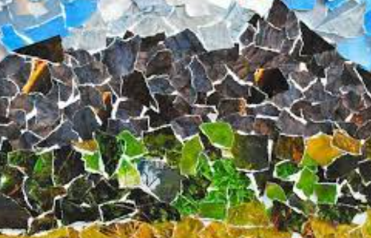
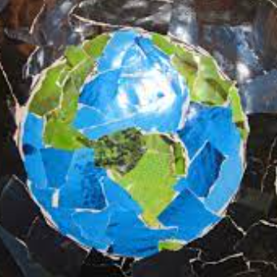

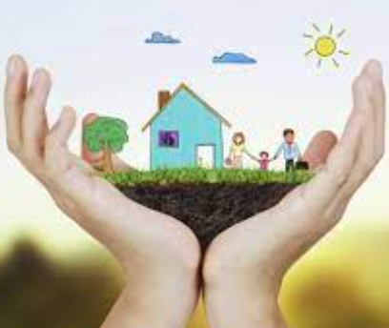

Developing Knowledge
Comparative theme |  |  | Working Towards | Within | Securely Within | Above
 |  | - To know why the world is a place of wonder
 |  | - To know that people have spoiled the natural world that many religious & non-religious people show concern about waste, greed and environmental issues.
 |  | - To know that non-religious people believe different things about how the world came to be.
Developing Skills
Engage |  |  | Working Towards | Within | Securely Within | Above
 |  | - To think about a nature documentary/ watch to discover what makes places wonderful and what wonderful natural things exist in our world.
 |  | - Read the picture book ‘Dinosaurs and all that rubbish’ (Michael Foreman) or similar to explore environmental issues with the class.
Enquire and explore |  |  | Working Towards | Within | Securely Within | Above
 |  | - To investigate whose world is it and whose job is it to look after the world?
 |  | - To investigate the story of creation from the Bible in Genesis to unpick who some people believe created the world.
Evaluate |  |  | Working Towards | Within | Securely Within | Above
 | - To reflect why we should look after our world and discuss and reflect on what would happen if we did not look after our world.
Express |  |  | Working Towards | Within | Securely Within | Above
 | - To express knowledge about the importance of looking after the world by creating a collage
Reflections: ____________________________________________________________________________________
______________________________________________________________________________________________

