

RE – Islam: Who is Allah and how do Muslims worship Him? (Year 1)
Outcome: Create a mind map showing what I have learnt about Allah and the Islamic faith.

Prior Knowledge and Skills
 | - To know that books are special to people who have different religions and beliefs
 | - To know the idea that God is understood in different ways by different people

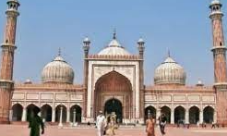
Vocabulary:
- Allah
- beautiful names
- pray
- prayer
- mosque
- Makkah

Ideas and inspiration:

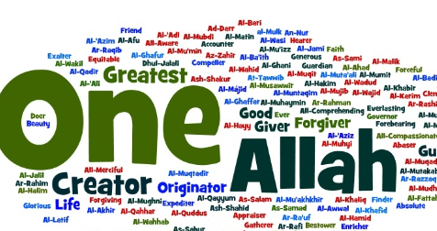
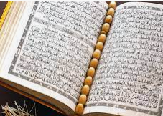

Developing Knowledge
Islam |  |  | Working Towards | Within | Securely Within | Above
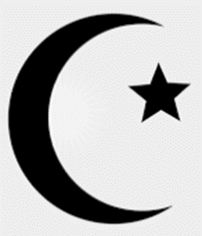 |  | - To know some of the 99 names and how these link to what Muslims believe about Allah
 |  | - To know that Muslims think it is better to represent Allah in words rather than pictures
 |  | - To know that Muslims believe it is important to be ritually clean before they pray
 |  | - To know that Muslims worship Allah through prayer
 |  | - To know that Muslims should face Makkah when they pray and have different physical positions in prayer to help them focus on Allah
Developing Skills
Engage |  |  | Working Towards | Within | Securely Within | Above
 |  | - To think about how your actions show that someone or something is important to you
Enquire and explore |  |  | Working Towards | Within | Securely Within | Above
 |  | - To investigate what Muslims say Allah is like
 |  | - To investigate how Muslims talk to Allah
Evaluate |  |  | Working Towards | Within | Securely Within | Above
 | - To reflect on why it might be important for some Muslims to meet at the mosque to pray together on a Friday
Express |  |  | Working Towards | Within | Securely Within | Above
 | - To express knowledge about Who Allah is and how Muslims worship Him
Reflections: ____________________________________________________________________________________
_____________________________________________________________________________________________

