

RE- What’s the Bible’s ‘big story’ – and why is it like treasure to Christians? (Year 3)
Outcome -to re-enact the main events from Palm Sunday thorough to Resurrection Sunday.

Outcome: To create a Parable quiz.

Prior Knowledge and Skills
 | - Know that Christians believe Jesus is the son of God.
 | - Know that the Bible is the Christian Holy book.

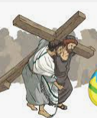
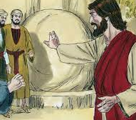
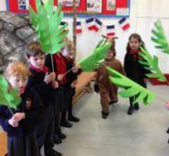
Ideas and inspiration:

Vocabulary:
- Palm Sunday
- triumphal entry
- Maundy Thursday,
- Passover
- sacrifice
- Last / Lord’s Supper
- Communion
- Crucifixion
- resurrection

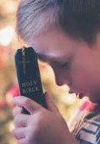

Developing Knowledge
Christianity |  |  | Working Towards | Within | Securely Within | Above
 |  | - To know that the Bible is a very old book, made up of different ‘books’ and stories, but all show Christians something about God.
 |  | - To know that Christians believe that the Bible tells one big (unfinished!) story from the creation of the World through to Jesus and it promises Jesus’ return.
 |  | - To know that the stories of Jesus’ birth, life, death and resurrection are the most important in this big story.
 |  | - To know about the events of Holy Week and Easter Sunday and their significance for Christians: Palm Sunday (e.g. triumphal entry, money changers), Passover meal, Good Friday (e.g. trial and crucifixion), Easter Sunday (e.g. resurrection).
Developing Skills
Engage |  |  | Working Towards | Within | Securely Within | Above
 |  | - To reflect on how words from the Bible impact how Christians live
 |  | - To reflect on why the Bible is like treasure to Christians.
 |  | - To reflect and think about the main events from Palm Sunday to Easter Day using a range of art expressing different parts of the story.
Enquire and explore |  |  | Working Towards | Within | Securely Within | Above
 |  | - To investigate links between the ‘Big Story’ and some things that Christians believe
 |  | - To investigate local church experiences/ individual pupil experiences.
Evaluate |  |  | Working Towards | Within | Securely Within | Above
 | - to relect on why stories about Jesus, might  - be considered most important to Christians.
Express |  |  | Working Towards | Within | Securely Within | Above
 | - To express an understanding of what happened using drama.
Reflections: ___________________________________________________________________________________
____________________________________________________________________________________________

