

RE – Why is the idea of rescue so important to Christians? (Year 6)
Outcome: represent ‘atonement’,’ rescue’ or ‘sacrifice’ (personal experiences of the children)

Prior Knowledge and Skills
 | - Christians remember Jesus’ death on Good Friday.
 | - Christians celebrate Jesus’ resurrection on Easter Day.


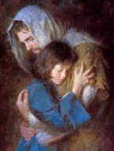

Vocabulary:
- sacrifice
- Passover
- atonement
- Gethsemane
- sin
- reconciliation
- salvation

Ideas and inspiration:

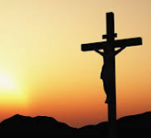

Developing Knowledge
Christianity |  |  | Working Towards | Within | Securely Within | Above
 |  | - To know that humans were made for relationship with God
 |  | - To know Jesus chose to die and is called Saviour
 |  | - To know Jesus died to show how much God loves people and wants to have a relationship with them
 |  | - To know that Jesus died to rescue or be an atonement for sin
Developing Skills
Engage |  |  | Working Towards | Within | Securely Within | Above
 |  | - To think about the word ‘salvation’(rescue) in the context of their own lives
Enquire and explore |  |  | Working Towards | Within | Securely Within | Above
 |  | - To investigate Jesus’ last words and why they are important to Christians
 |  | - Investigate what God’s solution was
Evaluate |  |  | Working Towards | Within | Securely Within | Above
 | - To reflect on how the salvation story might give Christians meaning in life
 | - To reflect on what Christians might need ‘rescuing’ from
Express |  |  | Working Towards | Within | Securely Within | Above
 | - To express knowledge and understanding through a creative response to ‘why is the idea of rescue so important?’
Reflections: ____________________________________________________________________________________
_____________________________________________________________________________________________

