

RE-How does Lent help Christians prepare for Easter? (Year 4)
Outcome- understand the importance of Lent.

Outcome: To create a Parable quiz.

Prior Knowledge and Skills
 | - Know about the events of Holy Week and Easter Sunday, and their significance for Christians.
 | - Know about the symbols associated with Easter and their links with what Christians believe about Jesus as King and Saviour.
Ideas and inspiration:

Vocabulary:
- Lent
- Ash Wednesday
- Mardi Gras
- Shrove Tuesday
- pancakes
- confession
- forgiveness
- temptation

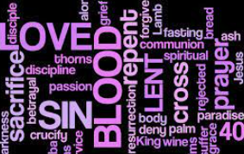
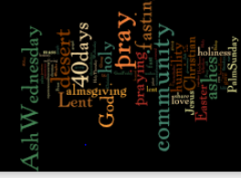
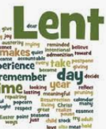

Developing Knowledge
Christianity |  |  | Working Towards | Within | Securely Within | Above
 |  | - To know the story of Jesus in the desert and its significance at Lent for Christians.
 |  | - To know that Lent is a time of preparation for Christians, marked in different ways.
 |  | - To know that Ash Wednesday is a time for Christians to seek God’s forgiveness.
 |  | - To know about the significance of the symbols and rituals used during Lent.
Developing Skills
Engage |  |  | Working Towards | Within | Securely Within | Above
 |  | - To reflect and think about how and when you have prepared for a special event.
Enquire and explore |  |  | Working Towards | Within | Securely Within | Above
 |  | - To investigate how Lent helps Christians to prepare for Easter.
 |  | - To investigate the story of Jesus in the desert and what this tells Christians.
 |  | - To investigate the ‘journey’ through lent.
Evaluate |  |  | Working Towards | Within | Securely Within | Above
 | - To reflect on how people celebrate Lent and consider whether Lent is just about giving something up or more.
 | - To reflect on their own thoughts about Lent with others in a sensitive manor.
Express |  |  | Working Towards | Within | Securely Within | Above
 | - To express the meaning of Lent through the vocabulary used by creating a Wordle.
Reflections: ______________________________________________________________________________________
_______________________________________________________________________________________________

Highlights: _______________________________________________________________________________________

_______________________________________________________________________________________________

