

RE-Why do Christians call Jesus Saviour? (Year 2)
Outcome- To understand the significance of Easter gardens.

Outcome: To retell a story from the Old Testament.

Prior Knowledge and Skills
 | - Know that on Good Friday Christians remember Jesus’ death
 | - Know that on Easter Day Christians celebrate Jesus’ resurrection

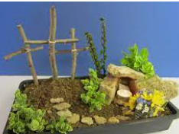
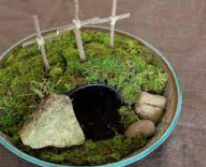
Vocabulary:
- cross
- Crucifixion
- Easter Garden
- sin
- forgiveness (restoration)
- tomb
- saviour

Ideas and inspiration:

Developing Knowledge
Christianity |  |  | Working Towards | Within | Securely Within | Above
 |  | - To know that Christians often call Jesus Saviour
 |  | - To know that the Bible contains stories about how Jesus met and ‘rescued’ people who were often poor, sick, friendless
 |  | - To know that Christians believe that Jesus’ resurrection means that death is not the end
 |  | - To know that Jesus’ offer of forgiveness is a part of the rescue at the heart of Easter
 |  | - To know that Christians believe that Jesus’ death means they can put things right with God again (be forgiven and ‘saved’)
 |  | - To know that the elements in an Easter garden are symbols of Jesus’ death and resurrection
Developing Skills
Engage |  |  | Working Towards | Within | Securely Within | Above
 |  | - To think about our experiences of being rescued or saved
 |  | - To think about how people who met Jesus felt
Enquire and explore |  |  | Working Towards | Within | Securely Within | Above
 |  | - To investigate the story of Zacchaeus and how his life was changed when he met Jesus
 |  | - To investigate the meaning and symbolism in an Easter garden
Evaluate |  |  | Working Towards | Within | Securely Within | Above
 | - To reflect on the impact of forgiveness on the Christian community
Express |  |  | Working Towards | Within | Securely Within | Above
 | - To express an understanding of salvation through symbols in an Easter garden
Reflections: ____________________________________________________________________________________
______________________________________________________________________________________________

