

RE-What can we learn from stories? ( EYFS)

Outcome: to retell the Easter story using drama.

Prior Knowledge and Skills
 | - Know that that Christians celebrate special festivals e.g. Harvest, Christmas, Easter and that other religions have different festivals
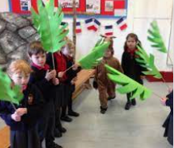
Vocabulary:

- Easter
- life
- Jesus
- born
- festivals
- belief

Ideas and inspiration:

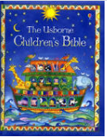

Christianity |  |  | Emerging | Expected
 |  | - To know that people have favourite stories.
 |  | - To know books that are special to people who have different religions and beliefs.
 |  | - To know the key parts of the Easter story using the children’s bible.
Engage |  |  | Emerging | Expected
 |  | - To think about what is my favourite story and why.
 |  | - To think about what I learn from stories I know.
Enquire and explore |  |  | Emerging | Expected
 |  | - To investigate what happens in the Easter story.
 |  | - To know the important people from the Easter story.
Evaluate |  |  | Emerging | Expected
 | - To reflect on what you learn from the Easter story and how this impacts Easter now.
Express |  |  | Emerging | Expected
 | - To express the key parts of the Easter story using Drama and role play.

Reflections: ____________________________________________________________________________________
______________________________________________________________________________________________

