

RE- Why is light important at Christmas? (Year 6)
Outcome- Understand the significance of ‘light VS dark’ by making a Christingle.

Outcome: To create a Parable quiz.

Prior Knowledge and Skills
 | - Know that Christians believe that God values human beings above anything else, which is why Jesus came, as a gift, to earth.
 | - Know that Christmas is the celebration of Jesus’ birth
 | - Know that the Bible contains a New Testament and an Old Testament.

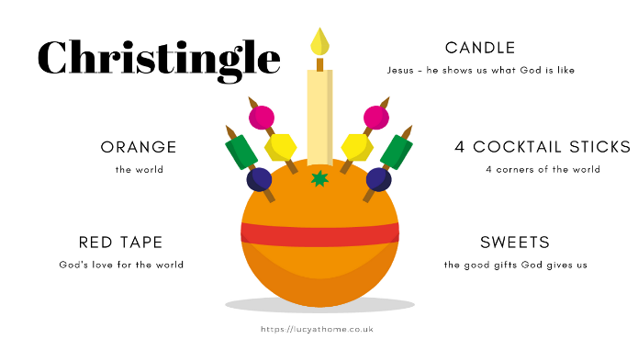
Vocabulary:
- symbolism
- sign
- light of the world
- nativity
- Festival of Light
- prophecy
- fulfilment
- Christingle service

Ideas and inspiration:

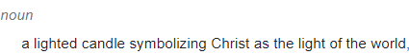

Developing Knowledge
Christianity |  |  | Working Towards | Within | Securely Within | Above
 |  | - To know about the different ways in which light is used as a sign at Christmas.
 |  | - To know about the significance of Jesus as the ‘Light of the World’ (John 8 v 12).
 |  | - To know that Christians believe that the birth of Jesus was a fulfilment of the Old Testament prophecy ‘A light for all people of the world’ (Isaiah 42 v5-6).
 |  | - To know that light is also used in other religions and festivals (Hanukah and Diwali).
Developing Skills
Engage |  |  | Working Towards | Within | Securely Within | Above
 |  | - To think about why and when we need light. Discuss ‘ light’ and ‘dark’ being used metaphorically.
Enquire and explore |  |  | Working Towards | Within | Securely Within | Above
 |  | - To investigate different ways that light is used at Christmas (advent candles, Christmas lights)
 |  | - To investigate Jesus’ words about being the light of the World and the symbolism of this.
Evaluate |  |  | Working Towards | Within | Securely Within | Above
 | - To reflect on why light is an important sign at Christmas.
Express |  |  | Working Towards | Within | Securely Within | Above
 | - To express a creative response to the topic of ‘light vs dark’ by engaging in a Christingle service.
Reflections: ___________________________________________________________________________________
____________________________________________________________________________________________

