

RE- What do Christians believe about the Messiah and why is it good news? (Year 5)
Outcome- Consider how the good news would be communicated in the modern world including Jesus as the fulfilment of prophecy.

Outcome: To create a Parable quiz.

Prior Knowledge and Skills
 | - Know that Christmas is the celebration of Jesus’ birth
 | - Know the key people and events in the nativity.

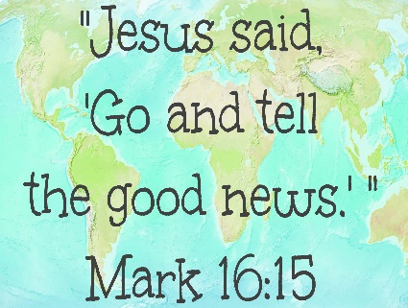
Ideas and inspiration:

Vocabulary:
- Gospel – good news
- Incarnation
- Salvation
- Messiah
- Luke
- Fulfilment
- prophecy

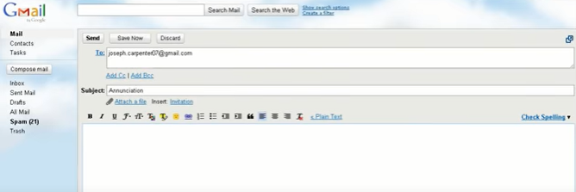

Developing Knowledge
Christianity |  |  | Working Towards | Within | Securely Within | Above
 |  | - To know that a prophecy is a message from God
 |  | - To know that most Christians believe that ancient prophecies in the Old Testament foretell the birth, life and death of Jesus
 |  | - To know that Jesus fulfilled many Old Testament prophecies, and because of this, Jesus is the ‘Messiah’
 |  | - To know that Jesus himself prophesied his death and resurrection
 |  | - To know how the words of Simeon in Luke 2 relate to prophecies about the Messiah
Developing Skills
Engage |  |  | Working Towards | Within | Securely Within | Above
 |  | - To think about what a prophet and prophecy are
Enquire and explore |  |  | Working Towards | Within | Securely Within | Above
 |  | - To investigate what Jesus says about himself and how this links to some prophecies.
 |  | - To investigate why the fulfilment of these prophecies might be good news for Christians.
Evaluate |  |  | Working Towards | Within | Securely Within | Above
 | - To reflect on why Jesus is at the centre of Christian worship
Express |  |  | Working Towards | Within | Securely Within | Above
 | - To express the idea of Jesus being the fulfilment of prophecy
Reflections: __________________________________________________________________________________________________
___________________________________________________________________________________________________________

