

RE-How can artists help us to understand what Christians believe? (Year 4)
Outcome- create a piece of artwork suitable for a stained glass window representing Christmas.

Outcome: To create a Parable quiz.

Prior Knowledge and Skills
 | - Know that Christmas is the celebration of Jesus’ birth
 | - Know the key people and events in the nativity.
- Know that Christians believe that God values human beings above anything else, which is why Jesus came, as a gift, to earth.
Vocabulary:
- belief
- Jesus
- nativity
- symbolism
- icons
- incarnate
- artists
- representation

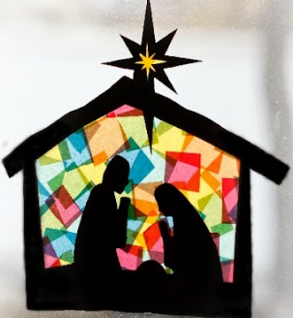
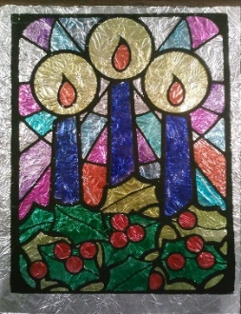
Ideas and inspiration:

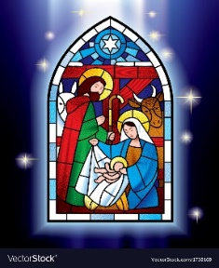

Developing Knowledge
Christianity |  |  | Working Towards | Within | Securely Within | Above
 |  | - To know that artists use symbolism to express the events of the nativity and Christian beliefs about Jesus.
 |  | - To know why artists have attempted to depict events surrounding the birth of Jesus.
 |  | - To know that the way in which artists around the world represent Christmas tells us the importance of Jesus as God ‘incarnate’.
Developing Skills
Engage |  |  | Working Towards | Within | Securely Within | Above
 |  | - To think about why people create art. Look at familiar art and discuss what the artist is trying to convey. Is art better than words?
Enquire and explore |  |  | Working Towards | Within | Securely Within | Above
 |  | - To investigate how different artists represent the events of Christmas.
 |  | - To investigate and match nativity scene artwork with relevant passages from the Bible about Jesus’ birth.
 |  | - To investigate the meanings of different Christmas art work (post it note comments).
Evaluate |  |  | Working Towards | Within | Securely Within | Above
 | - To reflect on how artists represent the birth of Jesus and how that helps us to understand Christmas.
Express |  |  | Working Towards | Within | Securely Within | Above
 | - To express artists meanings of the Christmas story within their own art work.

Reflections: _______________________________________________________________________________________
_______________________________________________________________________________________________

