

RE-What is the Nativity and why is it important to Christians? (Year 1)
Outcome-Retell the events of the Christmas Story.

Prior Knowledge and Skills
 | - Understand celebrations are joyful times.
 | - Know that Christians celebrate special festivals e.g. Harvest, Christmas, Easter.

Vocabulary:
- celebration
- birth
- Bethlehem
- Jesus
- Mary
- Joseph
- census
- inn
- innkeeper
- stable
- wise men

Ideas and inspiration:

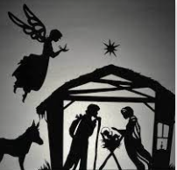

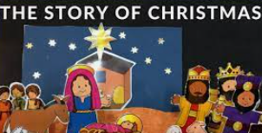

Developing Knowledge
Christianity |  |  | Working Towards | Within | Securely Within | Above
 |  | - To know that Christmas is linked to the account of the birth of Jesus as God’s son.
 |  | - To know the key people and events in the Nativity. (Mary, Joseph, Baby Jesus, Wise Men, Kings, Shepherds and Inn Keeper).
 |  | - To know that Christmas and the story of the nativity is a time of celebration for Christians.
Developing Skills
Engage |  |  | Working Towards | Within | Securely Within | Above
 |  | - To think about times of celebration and why they are important to people.
Enquire and explore |  |  | Working Towards | Within | Securely Within | Above
 |  | - To investigate what happens in the Nativity/ birth of Baby Jesus.
 |  | - To investigate a range of artists representation of the Christmas story.
Evaluate |  |  | Working Towards | Within | Securely Within | Above
 | - To reflect on why this time is important for Christians.
Express |  |  | Working Towards | Within | Securely Within | Above
 | - To express the key parts of the Christmas story.
Reflections: ___________________________________________________________________________________

____________________________________________________________________________________________

