

RE-Why do we have celebrations? (Rec)

Outcome: recognise a special celebration in my life.


Vocabulary:
- birthday
- gift
- celebration
- decoration
- feeling words (e.g. happy, excited)
- wedding
- Christmas
- Harvest
- Diwali
- Eid
- Chinese New Year

Ideas and inspiration:

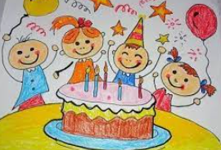

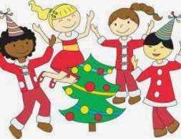
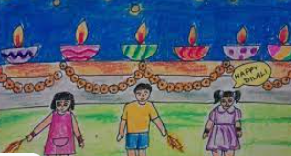

Christianity |  |  | Emerging | Expected
 |  | - To know that birthdays are important and that they celebrate their birth-day, the day they were born, once a year.
 |  | - To know a celebration is joyful and often a time to say “thank you”.
 |  | - To know that Christians celebrate special festivals e.g. Harvest, Christmas, Easter.
Engage |  |  | Emerging | Expected
 |  | - To think about how and why some festivals are celebrated
 |  | - To identify a time that is special to them
Enquire and explore |  |  | Emerging | Expected
 |  | - To investigate what times of the year Christians celebrate.
 |  | - To investigate the names of different festivals.
Evaluate |  |  | Emerging | Expected
 | - To reflect on their own experiences of celebrations.
Express |  |  | Emerging | Expected
 | - To express the key parts of celebrations (parties, presents, food, lights etc.)

Reflections: __________________________________________________________
_______________________________________________________________________________________________

