

RE-What do Christians believe about creation? (Year 6)
Outcome: To understand what Christians believe about creation, commenting on values and ways of life with regard to the care of the world/human sin.

Prior Knowledge and Skills
     | - Reflect on what Christians believe.
 | - Christians believe God is a creator
 | - To know that the Bible contains stories about God

https://www.bbc.co.uk/bitesize/topics/z9b2p9q/articles/zn7wmbk
Ideas and inspiration:

Vocabulary:
- humanity
- free will
- responsibility
- suffering
- the fall
- Genesis

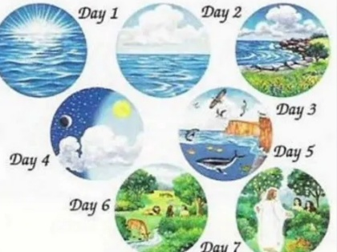
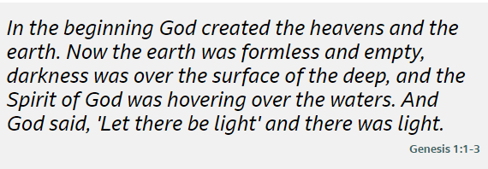

Developing Knowledge
Christianity |  |  | Working Towards | Within | Securely Within | Above
 |  | - To know that the creation narrative is shared by Jews, Christians and Muslims
 |  | - To know that most Christians believe that God created living things in 7 days and put humanity in charge of its care
 |  | - To know that humans are given free will and their choices have led to the fall of all creation
 |  | - To know that God will one day make ‘all things new’ and end all suffering
 |  | - To know that Christian views can differ both within and across denominations
Developing Skills
Engage |  |  | Working Towards | Within | Securely Within | Above
 |  | - To think about what it means to create
 |  | - To think about the difference between creation and the big bang
Enquire and explore |  |  | Working Towards | Within | Securely Within | Above
 |  | - To investigate what creation mean for Christians’ and their responsibility for living things
Evaluate |  |  | Working Towards | Within | Securely Within | Above
 | - To reflect on what creation means for Christians’ relationship with God?
Express |  |  | Working Towards | Within | Securely Within | Above
 | - To express knowledge and understanding of what Christians believe about creation
Reflections: ____________________________________________________________________________________

