

RE- For Christians, is Communion a celebration, or an act of remembrance? (Year 5)
Outcome: To write a prayer that could be said at the end of communion service, reflecting on what is important to Christians.

Prior Knowledge and Skills
     | - Know that the Bible tells stories about God, Jesus and people.
 | - Reflect on what Christians believe God is like.
 | - Investigate stories that Jesus told and identify their meanings.

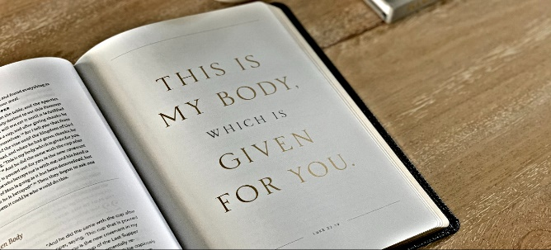
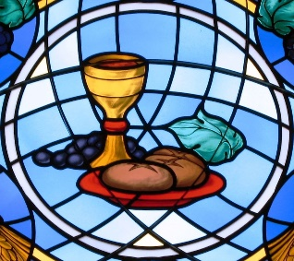
Vocabulary:
- bread (body
- wine (blood)
- symbol
- remembering
- sharing
- sacrifice
- communion sacrament, prayer, new agreement, forgiveness, Passover.

Ideas and inspiration:

Developing Knowledge
Christianity |  |  | Working Towards | Within | Securely Within | Above
 |  | - To know the meaning and some of the actions and words involved in communion.
 |  | - To know the story of Passover, the last supper and what Jesus said to his disciples.
Developing Skills
Engage |  |  | Working Towards | Within | Securely Within | Above
 |  | - To think about and describe how special family moments are celebrated e.g. birthday or family meals.
Enquire and explore |  |  | Working Towards | Within | Securely Within | Above
 |  | - To investigate the story of the last supper focusing on what Jesus said and did.
 |  | - To investigate links between communion and Passover
Evaluate |  |  | Working Towards | Within | Securely Within | Above
 | - To reflect on why Christians share communion.
 | - To reflect on own actions and the importance of ‘putting things right’.
Express |  |  | Working Towards | Within | Securely Within | Above
 | - To express knowledge and understanding of communion using some key phrases from the service.
Reflections: ___________________________________________________________________________________
_____________________________________________________________________________________________

