

RE- How did Jesus change lives and why is it good news? (Year 4)

Outcome: To reflect on one of Jesus’ miracles.

Prior Knowledge and Skills
   | - Know that the Bible tells stories about God, Jesus and people.
 | - Know that Jesus is the son of God.
 | - Investigate stories that Jesus told and identify their meanings.

Vocabulary:
- disciple
- follower
- miracle
- encounter
- outcast
- Son of God
- Saviour
- influence

Ideas and inspiration:

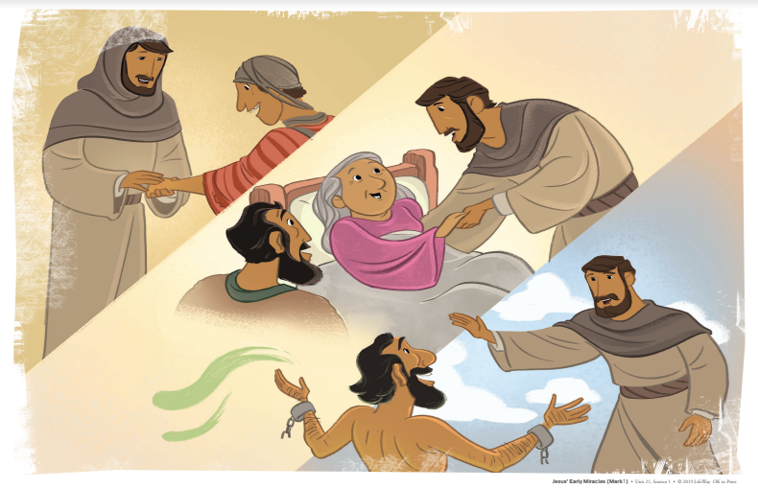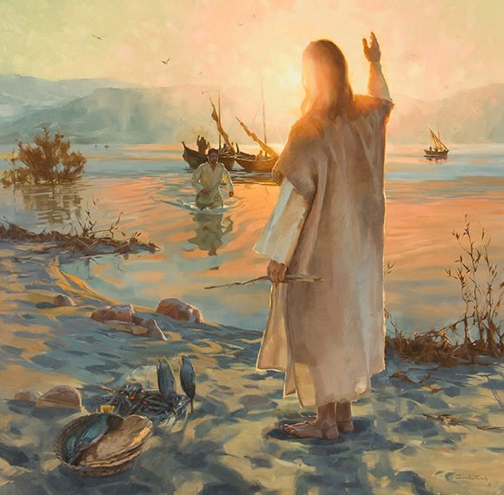




Developing Knowledge
Christianity |  |  | Working Towards | Within | Securely Within | Above
 |  | - To know that Jesus showed he was the son of God by performing miracles.
 |  | - To know that each miracle reveals something different about who Jesus is.
 |  | - To know that Jesus befriended ordinary people e.g. fishermen, and the ‘outcasts’ of society e.g. tax collectors, lepers, women.
Developing Skills
Engage |  |  | Working Towards | Within | Securely Within | Above
 |  | - To think about and describe how influence works.
 |  | - To identify who has changed your life and why.
Enquire and explore |  |  | Working Towards | Within | Securely Within | Above
 |  | - To investigate stories about the miracles that Jesus performed.
 |  | - The read the stories of The feeding of the 5000, The calming of the storm, Walking on water, healing the paralysed man.
 |  | - Investigate how non-religious people celebrate new life (Humanism).
Evaluate |  |  | Working Towards | Within | Securely Within | Above
 | - To reflect on the impact that Jesus’ miracles and encounters with different types of people has on the lives of Christians today.
Express |  |  | Working Towards | Within | Securely Within | Above
 | - To express knowledge and understanding of the miracles and the impact of Jesus on others.
Reflections: ___________________________________________________________________________________

_____________________________________________________________________________________________

