

RE-Why did Jesus tell parables? (Year 3)
Outcome: To create a Parable quiz.

Prior Knowledge and Skills
   | - Know that the Bible tells stories about God, Jesus and people.
 | - Investigate what God might be like using a range of sources.

Vocabulary:
- Jesus
- parable
- foolish
- wise
- prodigal son
- meaning
- truth
- love
- forgiveness

Ideas and inspiration:

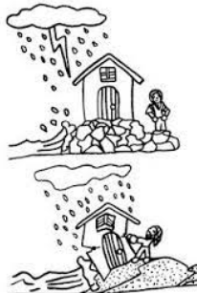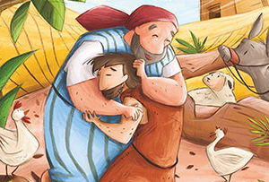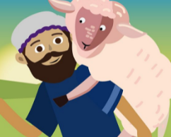

Developing Knowledge
Christianity |  |  | Working Towards | Within | Securely Within | Above
 |  | - To know that Jesus’ parables are found in the New Testament
 |  | - To know that parables have deep meanings.
Developing Skills
Engage |  |  | Working Towards | Within | Securely Within | Above
 |  | - To think about and describe favourite stories.
- To identify morals/meanings within stories.
(i.e. A Squash and a Squeeze)
Enquire and explore |  |  | Working Towards | Within | Securely Within | Above
 |  | - To investigate stories that Jesus told and identify their meanings
 |  | - To read the parables of The Good Samaritan, The Lost Sheep, The Wiseman and The Foolish man, The Prodigal Son.
Evaluate |  |  | Working Towards | Within | Securely Within | Above
 | - To reflect on what has been learnt from the parables.
Express |  |  | Working Towards | Within | Securely Within | Above
 | - To express knowledge and understanding of the meanings behind the parables.
Reflections: _____________________________________________________________________________________________
_______________________________________________________________________________________________________

