

RE-Why is the Bible an important book to Christians? (Year 2)
- Outcome: To express knowledge and understanding of key characters from the Old Testament.

Prior Knowledge and Skills
   | - Know that our world is a place of wonder that some people believe was created by God.
 | - Investigate what God might be like using a range of sources.

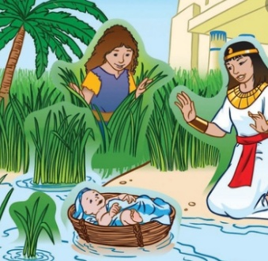
Ideas and inspiration:

The story of Moses. Daniel and the Lion’s Den

Vocabulary:
- image
- Bible
- God
- narrative
- story
- Old Testament
- New Testament
- book

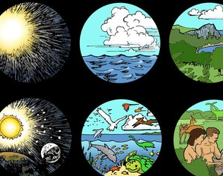
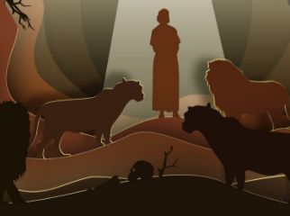

Developing Knowledge
Christianity |  |  | Working Towards | Within | Securely Within | Above
 |  | - To know that the Bible contains stories about God and people.
 |  | - To know the stories of Creation, Moses and Daniel in the lion’s den.
Developing Skills
Engage |  |  | Working Towards | Within | Securely Within | Above
 |  | - To think about and describe why books are important.
Enquire and explore |  |  | Working Towards | Within | Securely Within | Above
 |  | - To investigate the Bible.
 |  | - To establish that the Bible has two separate books.
 |  | - To read the stories of Joseph, Moses, David and Daniel.
 |  | - To suggest what Christians may learn from the Bible.
Evaluate |  |  | Working Towards | Within | Securely Within | Above
 | - To reflect on why the Bible is an important book
Express |  |  | Working Towards | Within | Securely Within | Above
 | - To express knowledge and understanding of stories and their key characters from the Old Testament.
Reflections: ___________________________________________________________________________________

_____________________________________________________________________________________________

