

RE-What is God like for Christians? (Year 1)

Outcome: To express ideas of what God is like.

Prior Knowledge and Skills
   | - Know that our world is a place of wonder that some people believe was created by God.
 | - Identify why and what people believe God created.

Vocabulary:
- Image
- Bible
- God
- Creator
- Adjective
- King
- Kingdom
- Christian
- Belief
- describe

Ideas and inspiration:
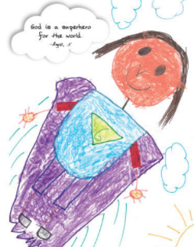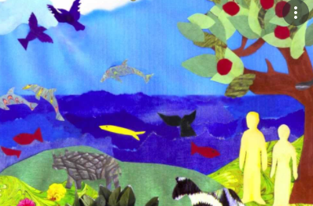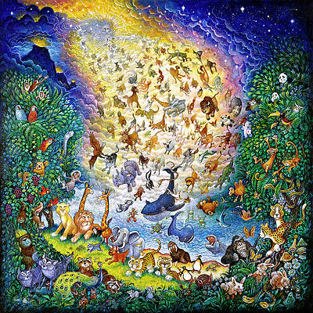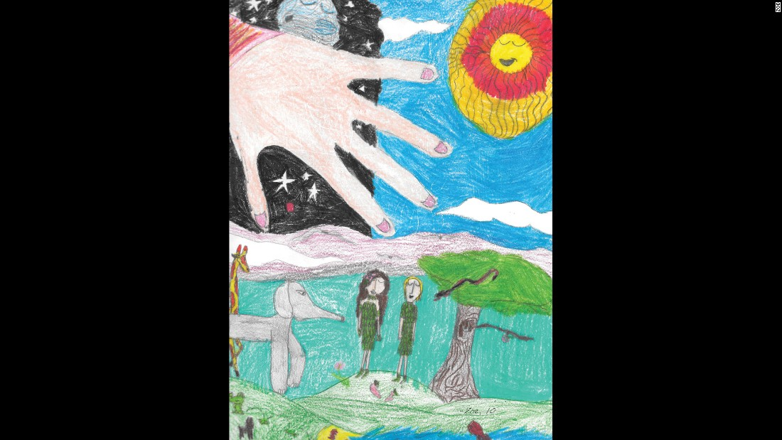

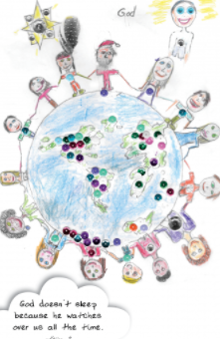

Mathew 18:10-14
2Corinthians 6:18

Developing Knowledge
Christianity |  |  | Working Towards | Within | Securely Within | Above
 |  | - To know that Christian beliefs about God are connected with words and images found in the Bible(creator, shepherd, father, King etc.)
 |  | - To know that most Christians believe God loves them and all people
Developing Skills
Engage |  |  | Working Towards | Within | Securely Within | Above
 |  | - To think about and describe different people and characters they know.
 |  | - To listen to others and express their thoughts and ideas about what God might be like
Enquire and explore |  |  | Working Towards | Within | Securely Within | Above
 |  | - To investigate what God might be like using a range of sources and artefacts.
Evaluate |  |  | Working Towards | Within | Securely Within | Above
 | - To reflect on what Christians believe God is like.
Express |  |  | Working Towards | Within | Securely Within | Above
 | - To express ideas and thoughts about God.
Reflections: ___________________________________________________________________________________

_____________________________________________________________________________________________

