
p

RE-What makes our world wonderful? (EYFS)

Outcome: To identify items of wonder that make us say ‘WOW’.

Vocabulary:
- God
- creation
- Bible
- story
- World
- wonder
- alive
- look after
- amazing
- unique
- special

Ideas and inspiration:
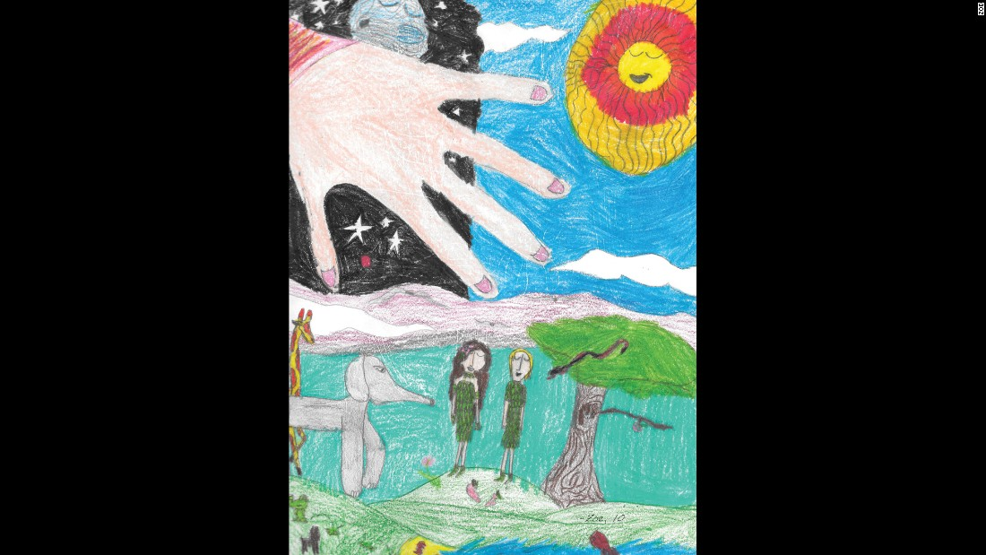



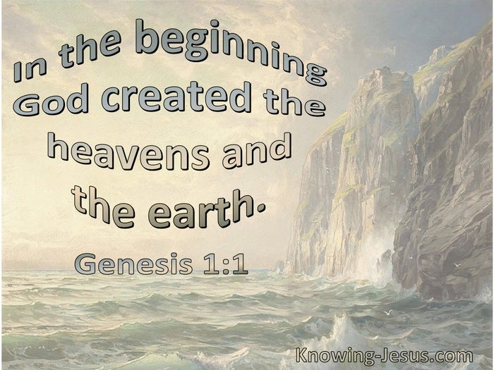

Christianity |  |  | Emerging | Expected
 |  | - To know that our world is a place of wonder that some people believe was created by God.
Engage |  |  | Emerging | Expected
 |  | - To think about a time they made something they were proud of.
Enquire and explore |  |  | Emerging | Expected
 |  | - To investigate and identify what in the world is wonderful.
 |  | - To identify why and what people believe God created
 |  | - To read the story of creation from the Bible.
Evaluate |  |  | Emerging | Expected
 | - To reflect on God’s creation of the World and all that is in it.
Express |  |  | Emerging | Expected
 | - To express ideas about what in the world is wonderful and what makes something wonderful.
Reflections: ___________________________________________________________________________________

_____________________________________________________________________________________________

