 | Reception | Year 1 | Year 2 | Year 3 | Year 4 | Year 5 | Year 6
Place Value  Practical resources  *Place value sliders  *Number cards  *flip cards  *double sided coins  *money | number, zero, one, two, three (to twenty) ten, twenty (to one hundred), none, count on, count up, count down, odd, even, greatest, biggest, smallest, largest, first, second (to tenth), buy, sell, penny, pence, pound, day, week, right, left | ones, units, tens, exchange, digit, ‘teens’ numbers, equal to, eleventh – twentieth, one hundred, half-way, between, sign, equals (=), number sentence, calculation, operation, place value, month, year | two hundred, three hundred (to one thousand), column, calculate, calculation, bought, sold, round, nearest, round to the nearest 10, integer, more than (>), less than (<) | value, worth, hundreds, one hundred more, one hundred less, approximate, approximately, amount, most/more expensive, less/least expensive, rounding | thousands, ten thousands, hundred thousands, million, numeral, decimal, decimal point, decimal place, increase, decrease, inverse, consecutive, negative, positive, place holder | greater than or equal to (≥), less than or equal to (≤), ascending/descending order, round to the nearest thousand, is approximately (≈), formula, units boundary, tenths boundary | factorise, thousandth, recurring, pro fit, loss
 | 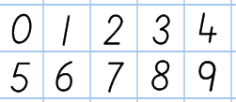 | 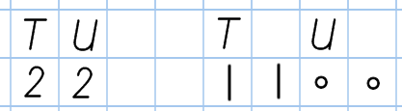 |  | 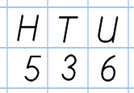 | 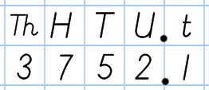 | 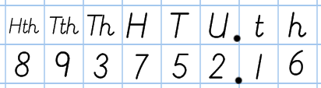 | 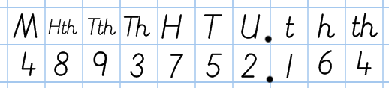
Addition  Practical resources  *dienes  *number lines  *100 square  *counting beads  *counting objects  *cubes  *double sided coins  *money | add, more, make, total, altogether, score, one more, two more, ten more, how many more to make | plus, (+), sum | addition, one hundred more, exchange | hundreds boundary | increase
 | 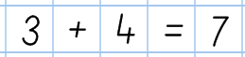 | 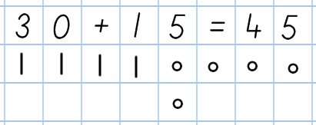 |  | 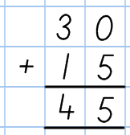  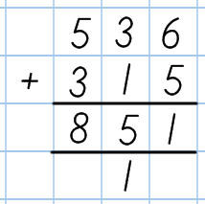 | 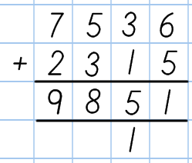 | 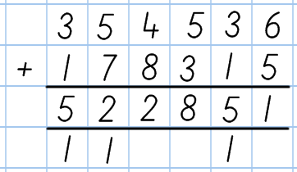 | 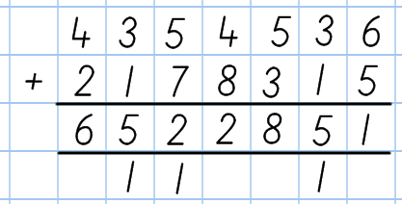
Subtraction  Practical resources  *dienes  *number lines  *100 square  *counting beads  *counting objects  *cubes  *double sided coin  *moneys | How many more is…than, take away, less, leave, how many left, one less, two less, 10 ten less, how many fewer, difference between, change, pay | How much more is, subtract (-) minus, how much less is, exchnage | tens boundary, one hundred less, subtraction, exchange |  | decrease
 | 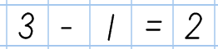 | 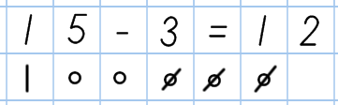 | 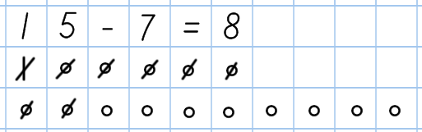 | 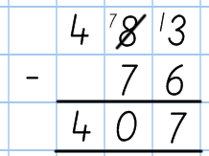 | 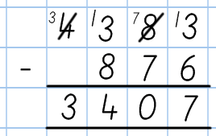 | 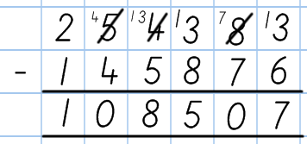 | 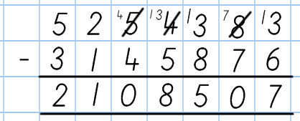
Multiplication  Practical resources  *multiplication grid  *Numicon  *counting beads  *double sided coins | half, halve, double, count in ones and twos | count in fives and tens, how many times | Count in threes, multiple of, lots of, groups of, times, multiply, multiplied by, repeated addition, array, row, column | Multiplication, product | factor, quotient, divisble by, inverse | square number, squared, cubed
 | 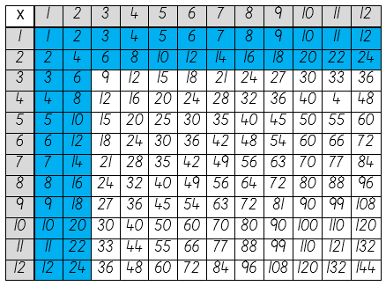  Tables: 1 and 2. | 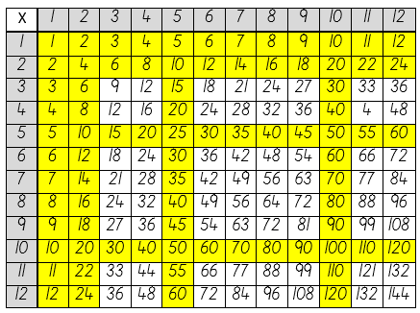  Tables: 1, 2, 5 and 10. | 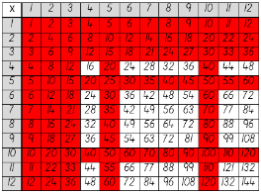  Tables: 1, 2, 3, 5 and 10. | 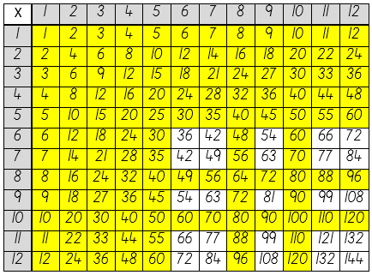  Tables: 1, 2, 3, 4, 5, 8 and 10. | 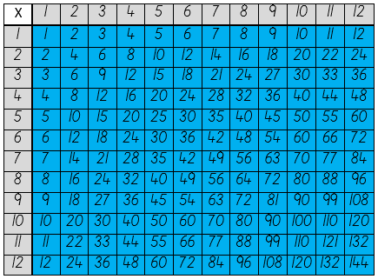  All tables. | 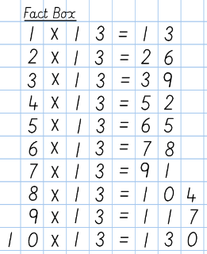
 |  | 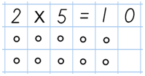 | 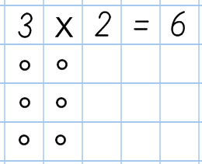 | 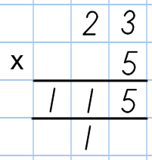 | 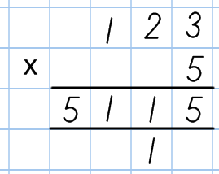 | 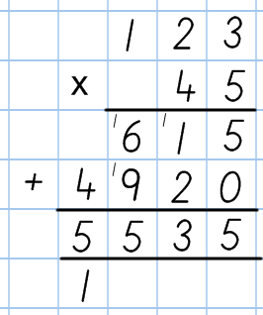  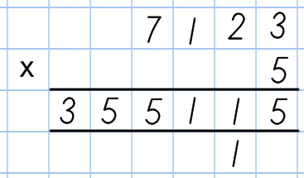
Division  Practical resources  *multiplication grid  *Numicon  *counting beads  *double sided coins |  |  | share equally, group in pairs, equal groups of, ÷, divide, divided by, divided into | division, remainder, left over |  | prime, prime factor
 |  | 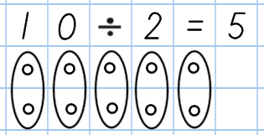 | 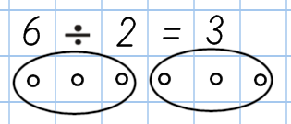 | 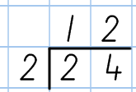 | 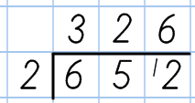  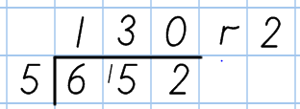 | 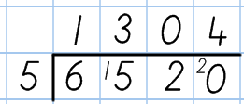  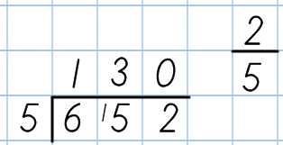 | 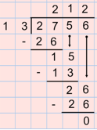
Fractions  Practical resources  *fraction wall  *multiplication grid |  |  | part, equal parts, fraction, one whole, one half, two halves, one quarter, two quarters, three quarters, four quarters | one third, two thirds, three thirds, one tenth, numerator, denominator | eighth, fifth, sixth, twentieth, proportion, in every, for every, proper/improper fraction, mixed number, equivalent, | reduced to, cancel, ninth, twelfth, hundredth, ratio
 |  |  | 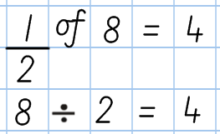 | 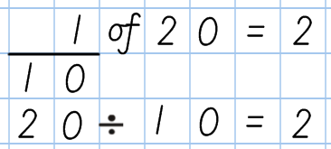 | 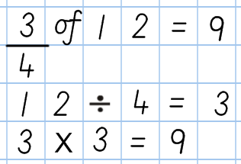 | 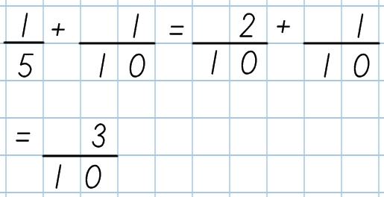  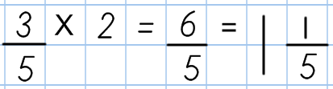  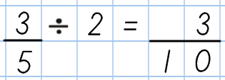 | 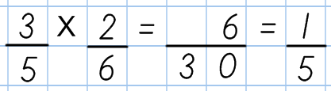  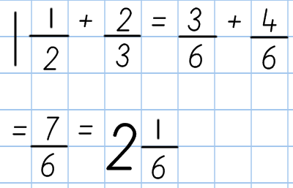
Decimals  Practical resources  *double sided coins  *place value sliders |  |  |  |  | decimal, decimal fraction, decimal point, decimal place, equivalent
 |  |  |  |  | 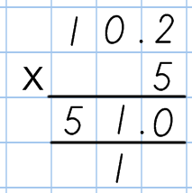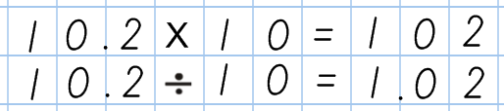 | 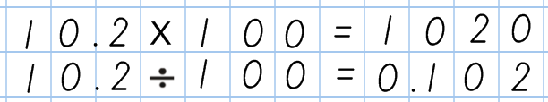  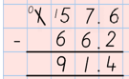  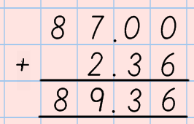 | 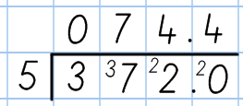  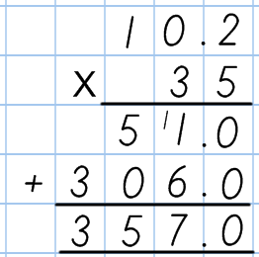
Percentages  Practical resources  *place value slider |  |  |  |  | percent | percentage, percent (%), equivalent
Percentages  Practical resources  *place value slider |  |  |  |  |  | 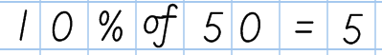 | 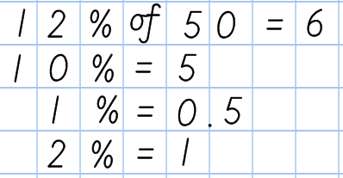
Order of operation  (BODMAS) |  |  |  |  |  | BODMAS, brackets, order
Order of operation  (BODMAS) |  |  |  |  |  | 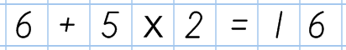 | 

