Chemistry | 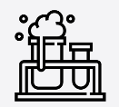


Science – Everyday materials (Year 1)

Outcome: Investigate which materials are the best to make an umbrella from.

Prior Knowledge and Skills
- Use all their senses in hands-on exploration of natural materials. (EYFS)
- Explore collections of materials with similar and/or different properties. (EYFS)
- Talk about the differences between materials and changes they notice. (EYFS)

  Ideas and inspiration:  Chester Greenwood (Inventor of earmuffs).  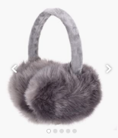  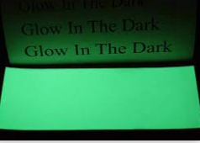  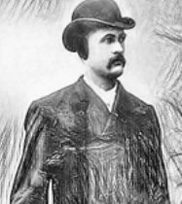  Becky Schroeder  (Inventor of Glo-sheets which she patented as a 12-year-old). |  | Vocabulary:  Object, material, wood, plastic, glass, metal, water, rock, brick, paper, fabric, elastic, foil, card/cardboard, rubber, wool, clay, hard, soft, stretchy, stiff, bendy, floppy, waterproof, absorbent, breaks/tears, rough, smooth, shiny, dull, see-through, not see-through

Developing Knowledge and Skills
Scientific Knowledge: |  | Working Towards | Within | Securely Within | Above
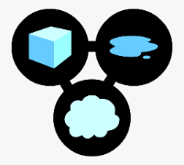 | - Distinguish between an object and the material from which it is made.
 | - Identify and name a variety of everyday materials, including wood, plastic, glass, metal, water, and rock.
 | - Describe the simple physical properties of a variety of everyday materials.
 | - Compare and group together a variety of everyday materials on the basis of their simple physical properties.
Working Scientifically (Skills): Do: |  | Working Towards | Within | Securely Within | Above
 | - Perform simple tests.
Working Scientifically (Skills): Record: |  | Working Towards | Within | Securely Within | Above
 | - Gather and record data to help in answering questions.
Working Scientifically (Skills): Review: |  | Working Towards | Within | Securely Within | Above
 | - Use observations and ideas to suggest answers to questions.
Working Scientifically (Enquiries): Identifying, grouping and classifying: |  | Working Towards | Within | Securely Within | Above
 | - Classify objects made from the same material (e.g. lots of things made from plastic).
 | - Classify one object made from different materials (e.g. cups made of different materials).
 | - Classify different fabrics based on texture.
 | - Classify paper/plastics/fabrics.
Working Scientifically (Enquiries): Comparative/ fair testing: |  | Working Towards | Within | Securely Within | Above
 | - Test objects made of different materials to see how effective they are e.g. umbrellas/hats/coats for waterproofness, cloths/nappies for absorbency, socks for elasticity, bounciness of balls, sunglasses for protection from the sun, picnic plates for stiffness, door mats for wiping your feet, different papers for writing on/painting etc.
Highlights: _________________________________________________________________________________________
___________________________________________________________________________________________________

