Biology | 


Science – Animals, including humans (Year 6)
Outcome: Use research to create a model/ poster explaining the functions of the heart, blood vessels and blood, recognising the impact of external features on these parts.

Prior Knowledge and Skills
- Describe the importance for humans of exercise, eating the right amounts of different types of food, and hygiene. (Y2 - Animals, including humans).
- Identify that animals, including humans, need the right types and amount of nutrition, and that they cannot make their own food; they get nutrition from what they eat. (Y3 - Animals, including humans).
- Describe the simple functions of the basic parts of the digestive system in humans. (Y4 - Animals, including humans).
- Identify the different types of teeth in humans and their simple functions. (Y4 - Animals, including humans).
- Report and present findings from enquiries, including conclusions, causal relationships and explanations of and degree of trust in results, in oral and written forms such as displays and other presentations. (Y5&6 skill).
- Use relevant scientific language and illustrations to discuss, communicate and justify their scientific ideas. (Y5&6 skill).

Ideas and inspiration:  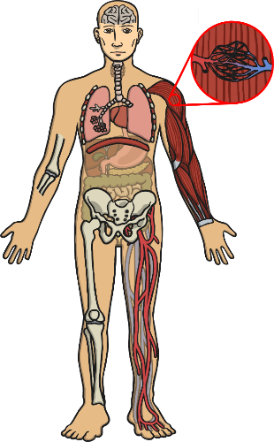  Richard Doll (Doctor who proved the link between lung cancer and smoking).  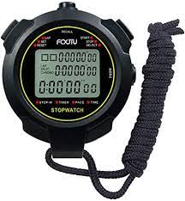  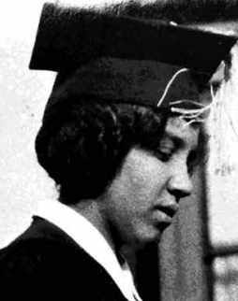  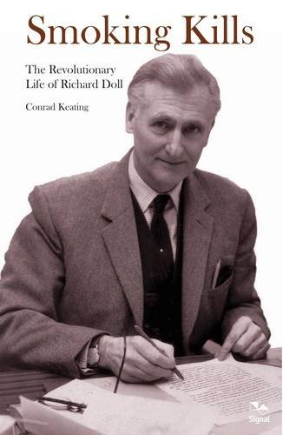  Ruth Ella Moore  (Bacteriologist who researched immunology, blood groups and tuberculosis). |  | Vocabulary:  Heart, pulse, rate, pumps, blood, blood vessels, veins, artery, capillaries, alveoli, gas exchange, villi, pulmonary, transported, lungs, oxygen, carbon dioxide, nutrients, water, muscles, cycle, circulatory system, diet, exercise, drugs, alcohol, tobacco, lifestyle

Developing Knowledge and Skills
Scientific Knowledge: |  | Working Towards | Within | Securely Within | Above
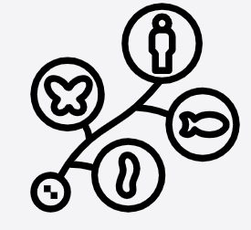 | - Identify and name the main parts of the human circulatory system, and describe the functions of the heart, blood vessels and blood.
 | - Recognise the impact of diet, exercise, drugs and lifestyle on the way their bodies function.
 | - Describe the ways in which nutrients and water are transported within animals, including humans.
Working Scientifically (Skills): Plan:  : |  | Working Towards | Within | Securely Within | Above
 | - Plan different types of scientific enquiries to answer questions, including recognise and controlling variables where necessary.
Working Scientifically (Skills): Record:
 | - Record data and results of increasing complexity using scientific diagrams and labels, classification keys, tables, scatter graphs, bar and line graphs.
Working Scientifically (Enquiries): Observing over time
 | - Observe pulse rates before, during and after exercise.
Working Scientifically (Enquiries) Pattern seeking
 | - Generate questions for investigation, such as:  Do older people have lower pulse rates?  Do boys have higher pulse rates?
Working Scientifically (Enquiries): Comparative/ fair testing: |  | Working Towards | Within | Securely Within | Above
 | - Complete various activities to compare impact on their own heart rate.
Working Scientifically (Enquiries): Researching
 | - Generate questions to research about the human circulatory system.
Highlights: _________________________________________________________________________________________
___________________________________________________________________________________________________

