Biology | 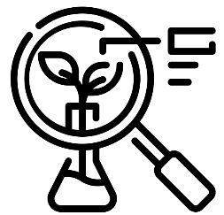


Science – Animals, including humans (Year 5)
Outcome: Understand the human life cycle and use this knowledge in RSE week to explain changes in body.

Prior Knowledge and Skills
- Notice that animals, including humans, have offspring which grow into adults. (Y2 - Animals, including humans)
- Being unique. (PSHE – Y4, Changing Me)
- Girls and puberty. (PSHE – Y4, Changing Me)

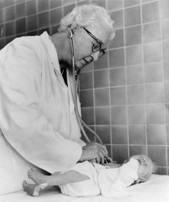  Ideas and inspiration:  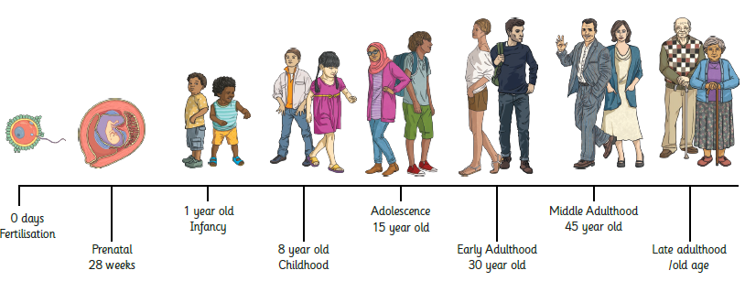  Virginia Apgar (Doctor & Medical Researcher who developed a method of evaluating the well-being of new-born babies). |  | Vocabulary:  Fertilisation, prenatal, infancy, toddler childhood, adolescence, teenage, adult/ adulthood, elderly, old age, puberty, gestation, foetus, baby, reproduction, offspring, growth, life expectancy, life cycle

Developing Knowledge and Skills
Scientific Knowledge: |  | Working Towards | Within | Securely Within | Above
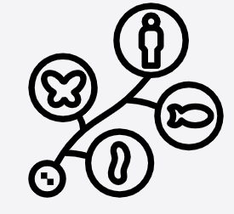 | - Describe the changes as humans develop to old age.
 | - Explain the changes that take place in boys and girls during puberty (link RSE).
 | - Explain how a baby changes physically as it grows, and also what it is able to do.
Working Scientifically (Skills): Review: |  | Working  Towards | Within | Securely Within | Above
 | - Use relevant scientific language and illustrations to discuss, communicate and justify their scientific ideas.
Working Scientifically (Enquiries): Researching |  | Working Towards | Within | Securely Within | Above
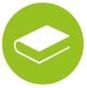 | - Develop questions to ask in RSE week.
Highlights: _________________________________________________________________________________________
___________________________________________________________________________________________________

