Physics | 


Science – Sound (Year 4)
Outcome: Use my knowledge of sound to create a string telephone.

Prior Knowledge and Skills
- Explore how things work. (EYFS)
- Describe what they see, hear and feel whilst outside. (EYFS)
- Identify, name, draw and label the basic parts of the human body and say which part of the body is associated with each sense. (Y1 - Animals, including humans)

Ideas and inspiration: https://www.youtube.com/watch?v=JWB_-wevjSY  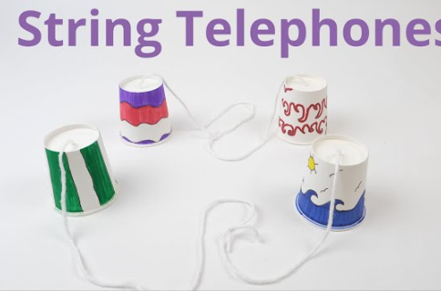  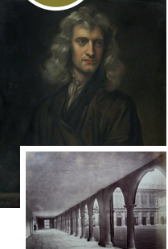  Isaac Newton – mathematician & physicist who measured the speed of sound.  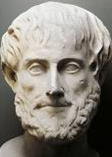  Aristotle (Greek Philosopher who developed the concept that sound travels through air due to the movement of air particles) |  | Vocabulary:  sound, source, vibrate, vibration, travel, pitch (high, low), volume, faint, loud, insulation

Developing Knowledge and Skills
Scientific Knowledge: |  | Working Towards | Within | Securely Within | Above
 | - Identify how sounds are made, associating some of them with something vibrating.
 | - Recognise that vibrations from sounds travel through a medium to the ear.
 | - Find patterns between the pitch of a sound and features of the object that produced it.
 | - Find patterns between the volume of a sound and the strength of the vibrations that produced it.
 | - Recognise that sounds get fainter as the distance from the sound source increases.
Working Scientifically (Skills): Plan:  : |  | Working Towards | Within | Securely Within | Above
 | - Ask relevant questions and using different types of scientific enquiries to answer them.
 | - Set up simple practical enquiries, comparative and fair tests.
Working Scientifically (Skills): Do: |  | Working Towards | Within | Securely Within | Above
 | - Make systematic and careful observations and, where appropriate, take accurate measurements using standard units, using a range of equipment, including thermometers and data loggers.
Working Scientifically (Skills): Review: |  | Working Towards | Within | Securely Within | Above
 | - Use results to draw simple conclusions, make predictions for new values, suggest improvements and raise further questions.
 | - Use straightforward scientific evidence to answer questions or to support their findings.
Working Scientifically (Enquiries): Classifying: |  | Working Towards | Within | Securely Within | Above
 | - Sort musical instruments according to own criteria.
Working Scientifically (Enquiries): Comparative/ fair testing: |  | Working Towards | Within | Securely Within | Above
 | - Measure volume from different instruments.
 | - Measure how volume changes away from a source.
 | - Investigate string telephones.
 | - Explore pitch e.g. through a carousel of activities using milk bottles, straw pipes, rulers, elastic band guitars.
Working Scientifically (Enquiries): Researching: |  | Working Towards | Within | Securely Within | Above
 | - Research, make and play their own instruments based on what they learned about pitch and volume.
Highlights: _________________________________________________________________________________________
___________________________________________________________________________________________________

