Physics | 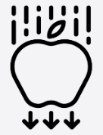


Science – Light (Year 3)

Outcome: Use my knowledge of light and shadow to create a sundial.

Prior Knowledge and Skills
- Explore how things work. (EYFS)
- Talk about the differences in materials and changes they notice. (EYFS)
- Describe what they see, hear and feel whilst outside. (EYFS)
- Identify, name, draw and label the basic parts of the human body and say which part of the body is associated with each sense. (Y1 - Animals, including humans)
- Describe the simple physical properties of a variety of everyday materials. (Y1 - Materials)

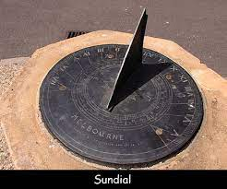  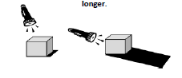  Ideas and inspiration:  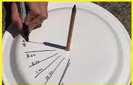  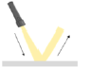  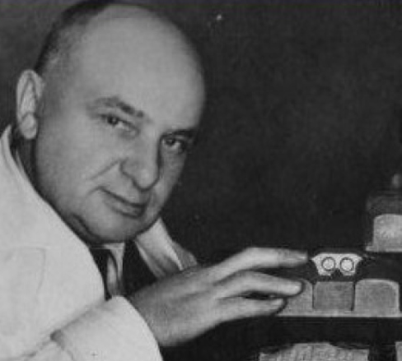  Percy Shaw (Inventor of the cat’s eye) |  | Vocabulary:  Light, light source, dark, absence of light, transparent, translucent, opaque, shiny, matt, surface, shadow, reflect, mirror, sunlight, dangerous

Developing Knowledge and Skills
Scientific Knowledge: |  | Working Towards | Within | Securely Within | Above
 | - Recognise that they need light in order to see things, and that dark is the absence of light.
 | - Notice that light is reflected from surfaces.
 | - Recognise that light from the sun can be dangerous and that there are ways to protect their eyes.
 | - Recognise that shadows are formed when the light from a light source is blocked by an opaque object.
 | - Find patterns in the way that the size of shadows change.
Working Scientifically (Skills): Plan:  : |  | Working Towards | Within | Securely Within | Above
 | - Begin to look for naturally occurring patterns and relationships and decide what data to collect to identify them.
 | - Set up simple practical enquiries, comparative and fair tests. Recognise when a simple fair test is necessary and help to decide how to set it up.
Working Scientifically (Skills): Record: |  | Working Towards | Within | Securely Within | Above
 | - Record findings using simple scientific language, drawings, labelled diagrams, keys, bar charts, and tables.
Working Scientifically (Skills): Review: |  | Working Towards | Within | Securely Within | Above
 | - Report on findings from enquiries, including oral and written explanations, displays or presentations of results and conclusions.
Working Scientifically (Enquiries): Identifying, grouping, and classifying: |  | Working Towards | Within | Securely Within | Above
 | - Classify light sources (leading to man-made/ natural).
 | - Classify materials (leading to reflective/ non-reflective, transparent/ translucent/ opaque).
Working Scientifically (Enquiries): Comparative/ fair testing: |  | Working Towards | Within | Securely Within | Above
 | - Test materials for reflectiveness.
 | - Test materials for transparency.
 | - Investigate shadows (size of shadows, shape of shadows).
Highlights: _________________________________________________________________________________________
___________________________________________________________________________________________________

