Physics | 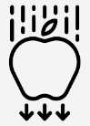


Science – Forces and magnets (Year 3)

Outcome: Conduct an investigation to identify magnetic objects in the environment.

Prior Knowledge and Skills
- Explore the natural world around them. (EYFS – Forces)
- Describe what they see, hear and feel whilst outside. (EYFS – Forces)
- Find out how the shapes of solid objects made from some materials can be changed by squashing, bending, twisting and stretching. (Y2 - Uses of everyday materials)

Ideas and inspiration:  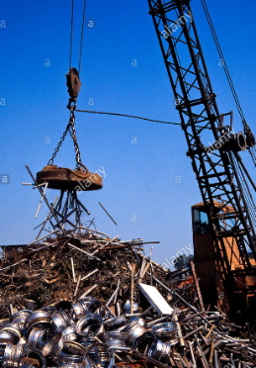  William Gilbert (Doctor who developed the theory of magnetism) .  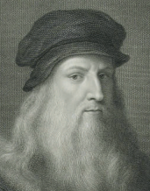  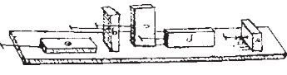  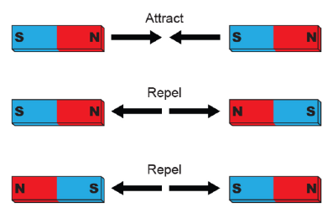  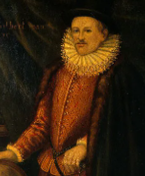Leonardo Da Vinci (First person to plan and carry out tests on friction). |  | Vocabulary:  Force, push, pull, twist, contact force, non-contact force, magnetic force, magnet, strength, bar magnet, ring magnet, button magnet, horseshoe magnet, attract, repel, magnetic material, metal, iron, steel, poles, north pole, south pole

Developing Knowledge and Skills
Scientific Knowledge: |  | Working Towards | Within | Securely Within | Above
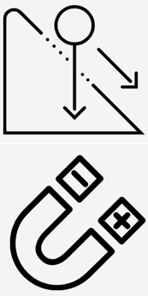 | - Compare how things move on different surfaces.
 | - Notice that some forces need contact between two objects, but magnetic forces can act at a distance
 | - Observe how magnets attract or repel each other and attract some materials and not others.
 | - Compare and group together a variety of everyday materials on the basis of whether they are attracted to a magnet, and identify some magnetic materials.
 | - Describe magnets as having two poles.
 | - Predict whether two magnets will attract or repel each other, depending on which poles are facing.
Working Scientifically (Skills): Plan:  : |  | Working Towards | Within | Securely Within | Above
 | - Set up simple practical enquiries, comparative and fair tests.
Working Scientifically (Skills): Do: |  | Working Towards | Within | Securely Within | Above
 | - Make systematic and careful observations and, where appropriate, take accurate measurements using standard units, using a range of equipment, including thermometers and data loggers.
Working Scientifically (Skills): Record: |  | Working Towards | Within | Securely Within | Above
 | - Gather, record, classify and present data in a variety of ways to help in answering questions.
Working Scientifically (Skills): Review: |  | Working Towards | Within | Securely Within | Above
 | - Report on findings from enquiries, including oral and written explanations, displays or presentations of results and conclusions.
Working Scientifically (Enquiries): Identifying, grouping, and classifying: |  | Working Towards | Within | Securely Within | Above
 | - Sort materials (leading towards metal/non-metal and magnetic/not magnetic).
 | - Sort toys (leading to what makes them move e.g. push/pull).
Working Scientifically (Enquiries): Comparative/ fair testing: |  | Working Towards | Within | Securely Within | Above
 | - Test how objects move on different surfaces (e.g. cars, spinning tops, wind-up/ clockwork toys).
 | - Test the strength of different magnets
Working Scientifically (Enquiries): Researching
 | - Find out how magnets are used in everyday life.
Highlights: _________________________________________________________________________________________
___________________________________________________________________________________________________

