Biology | 


Science – Animals, including humans (Year 3)
Outcome: Understand the importance of bones and muscles and create a skeleton model.

Prior learning
- Notice that animals, including humans, have offspring which grow into adults. (Y2 - Animals, including humans)
- Find out about and describe the basic needs of animals, including humans, for survival (water, food and air). (Y2 - Animals, including humans)
- Describe the importance for humans of exercise, eating the right amounts of different types of food, and hygiene. (Y2 - Animals, including humans)

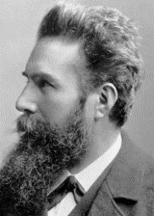    Ideas and inspiration:  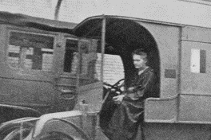  Wilhelm Roentgen (Physicist who discovered x-rays)    Marie Curie (Physicist who invented the first mobile x-ray machine to treat soldiers wounded on the battlefield in WWI)  Adelle Davis (Biochemist & Nutritionist who linked health and diet) |  | Vocabulary:  •Food groups and nutrients: fibre, fats (saturated and unsaturated), vitamins, minerals.  •Skeletons and muscles: skeleton, muscles, tendons, joints, protection, support, organs, voluntary muscles, involuntary muscles, biceps, triceps, contract, relax, bone, cartilage, shell, vertebrate, invertebrate, endoskeleton, exoskeleton, hydrostatic skeleton.  •Names of human bones: e.g. skull, spine, backbone, vertebral column, ribcage, pelvis, clavicle, scapula, humerus, ulna, pelvis, radius, femur, tibia, fibula.  •Other: energy  •Previously introduced vocabulary: movement
  Enquiries:
  Identifying, grouping and classifying  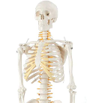    - Classify food items (leading to sorting by nutrients)  - Classify animals (leading to sorting by whether or not they have skeletons). |   Pattern seeking  -Generate questions for investigation such as:  ▪ Can people with short legs jump higher?  ▪ Can people with longer legs run faster? | Researching    -Look at food packaging to identify the amount of nutrients in different food items.

Developing Knowledge and Skills
Scientific Knowledge: |  | Working Towards | Within | Securely Within | Above
 | - Identify that animals, including humans, need the right types and amount of nutrition, and that they cannot make their own food; they get nutrition from what they eat.
 | - Identify that humans and some other animals have skeletons and muscles for support, protection and movement.
Working Scientifically (Skills): Plan |  | Working Towards | Within | Securely Within | Above
 | - Ask relevant questions and use different types of scientific enquiries to answer them.
 | - Start to make their own decisions about the most appropriate type of scientific enquiry they might use to answer questions.
Working Scientifically (Skills): Do |  | Working Towards | Within | Securely Within | Above
   | - Set up simple practical enquiries, comparative and fair tests.
 | - Recognise when a simple fair test is necessary and help to decide how to set it up.
Working Scientifically (Skills): Review |  | Working Towards | Within | Securely Within | Above
 | - Use results to draw simple conclusions, make predictions for new values, suggest improvements and raise further questions.
How did your learning in Year 2 help you with your learning about animals in Year 3? __________________________
___________________________________________________________________________________________________
Is there anything else you would like to know about animals? _____________________________________________
___________________________________________________________________________________________________
Highlights: _________________________________________________________________________________________
___________________________________________________________________________________________________

