Biology | 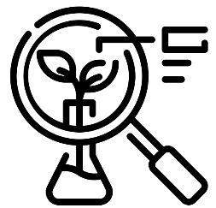


Science – Plants (Year 3)
Outcome: Understand the plant lifecycle and investigate how water is transported in plants using observations.

Prior learning
- Observe and describe how seeds and bulbs grow into mature plants.
- Find out and describe how plants need water, light and a suitable temperature to grow and stay healthy.
- Explore and compare the differences between things that are living, dead, and things that have never been alive.
- Identify that most living things live in habitats to which they are suited and describe how different habitats provide for the basic needs of different kinds of animals and plants, and how they depend on each other.
- Identify and name a variety of plants and animals in their habitats, including micro-habitats.

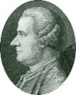
Vocabulary:
Water transportation: transport, evaporation, evaporate, nutrients, absorb, anchor.

Life cycle of flowering plants: pollination (insect/wind), pollen, nectar, pollinator, seed formation, seed dispersal (animal/wind/water), reproduce, fertilisation, fertilise, stamen, anther, filament, carpel (pistil), stigma, style, ovary, ovule, sepal, carbon dioxide.

Previously introduced vocabulary: life cycle.

Ideas and inspiration:

Jan Ingenhousz (Doctor & Scientist who discovered the
process of photosynthesis)
Dr Kelsey Byers (Biologist who studies flower smells
and how they attract insects)
Enquiries:
Identifying, grouping and classifying  - Classify flowers based on the children’s own criteria.   | Observing over time  -Observe celery (with roots and leaves) in coloured water.  -Observe white carnations (freshly cut) in coloured water.  -Gather seeds and photographic evidence of blossoms/flowers and berries on a particular trail throughout the year. | Pattern seeking  - Investigate what happens when conditions are changed e.g. more/less light/water, change in temperature, nutrients (Baby Bio vs other brands). | Researching  - Research the functions of the parts of flowering plants.  -Research different methods of seed dispersal.  Research different methods of pollination.

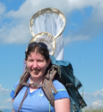




Developing Knowledge and Skills
Scientific Knowledge: |  | Working Towards | Within | Securely Within | Above
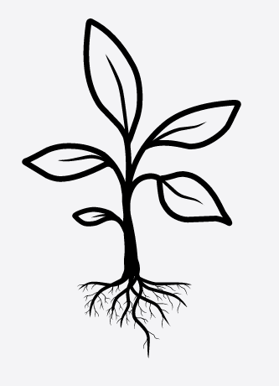 | - identify and describe the functions of different parts of flowering plants: roots, stem/trunk, leaves and flowers
 | - explore the requirements of plants for life and growth (air, light, water, nutrients from soil, and room to grow) and how they vary from plant to plant
 | - investigate the way in which water is transported within plants
 | - explore the part that flowers play in the life cycle of flowering plants, including pollination, seed formation and seed dispersal
Working Scientifically: Plan |  | Working Towards | Within | Securely Within | Above
 | - Set up simple practical enquiries, comparative and fair tests.
Working Scientifically: Do |  | Working Towards | Within | Securely Within | Above
 | - Make systematic and careful observations and, where appropriate, take accurate measurements using standard units.
 | - Begin to look for naturally occurring patterns and relationships and decide what data to collect to identify them.
Working Scientifically: Review |  | Working Towards | Within | Securely Within | Above
     | - Report on findings from enquiries, including oral and written explanations, displays or presentations of results and conclusions.
Highlights: ______________________________________________________________________________________

