Biology | 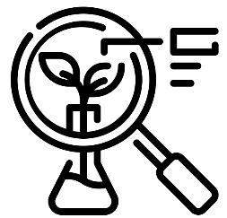


Science – Plants (Year 2)
Outcome: Plant seeds/bulbs and make observations providing evidence about what plants need to survive.

Prior learning
- Identify and name a variety of common wild and garden plants, including deciduous and evergreen tree. (EYFS/Y1)
- Identify and describe the basic structure of a variety of common flowering plants, including trees. (EYFS/Y1)

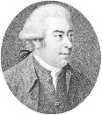
Ideas and inspiration:
Sir Joseph Banks (Naturalist on Captain Cook’s voyage around the World)
Poppy Okotcha (Horticulturalist interested in
the connection between healthy environments,
healthy food, and healthier people)
Dr Angie Burnett (Plant Biologist who grows plants and sees how they react to different conditions that make it more difficult for them to grow)
Enquiries:
Identifying, grouping and classifying  -Classify seeds and bulbs (using own criteria)   | Observing over time  -Observe a trail/patch  to identify how plants change through the year. | Pattern seeking  -Generate questions  for investigation such as:  - Do big seeds germinate more quickly?  - Does it matter which way round you plant a bulb or seed?  - Which comes first, the root or the shoot? | Researching  - Look at packets to decide how to plant and care for seeds e.g. How much water do they need? Do they need shade/full sun?

Vocabulary:
Growth of plants: germination, shoot, seed dispersal, grow, food store, life cycle, die, wilt, seedling, sapling.
Needs of plants: sunlight, nutrition, light, healthy, space, air.

Name different types of plant: e.g. bean plant, cactus.

Names of different habitats: e.g. rainforest, desert.

Previously introduced vocabulary: water, temperature, warm, hot, cold, habitat.


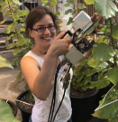




Developing Knowledge and Skills
Scientific Knowledge: |  | Working Towards | Within | Securely Within | Above
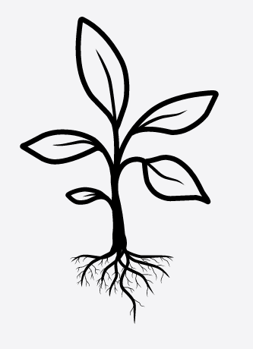 | - Observe and describe how seeds and bulbs grow into mature plants.
 | - Find out and describe how plants need water, light and a suitable temperature to grow and stay healthy.
Working Scientifically: Do |  | Working Towards | Within | Securely Within | Above
 | - Observe changes over time closely, using simple equipment.
 | - Use simple features to compare living things.
 | - With help, decide how to sort and group features, observe changes over time, and, with guidance, notice patterns and relationships.
Working Scientifically: Record |  | Working Towards | Within | Securely Within | Above
   | - Gather and record data to help in answering questions.
Working Scientifically: Review |  | Working Towards | Within | Securely Within | Above
     | - Use observations and ideas to suggest answers to questions.
Highlights: _______________________________________________________________________________

