
Vocabulary:

Classifying: Carl Linnaeus, Linnaean system, flowering and non-flowering plants, variation.
Microorganisms: bacteria,
single-celled, microbes, microscopic, virus, fungi, fungus, mould, antibiotic, yeast, ferment, microscope, decompose

Science – Livings things and their habitats (Year 6)

Outcome: Use classification system to classify animal(s)/ plant(s) e.g. Linnaeus System

Prior learning
- Describe the differences in the life cycles of a mammal, an amphibian, an insect and a bird. (Y5 – Living things and their habitats)
- Describe the life process of reproduction in some plants and animals. (Y5 – Living things and their habitats)
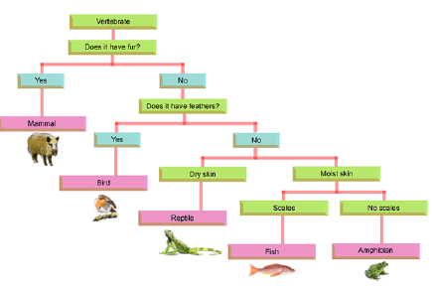
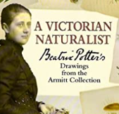
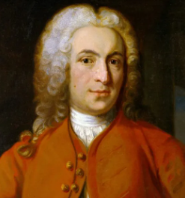
Ideas and inspiration:

Carl Linnaeus (Botanist & Zoologist who developed a taxonomy for classifying organisms)
Beatrix Potter (Mycologist, study of fungi, and Scientific Illustrator)
Enquiries
Identifying, grouping and classifying  - Create a branching database/dichotomous key to  classify a set of living things. | Researching  - Research unusual animals  e.g. axolotl, platypus, kangaroos  etc.

Developing Knowledge and Skills
Scientific Knowledge: |  | Working Towards | Within | Securely Within | Above
 | - Describe how living things are classified intro broad groups according to common observable characteristics and based on similarities and differences, including micro-organisms, plants and animals.
 | - Give reasons for classifying plants and animals based on specific characteristics.
Working Scientifically: Do |  | Working Towards | Within | Securely Within | Above
 | - Use and develop keys and other information records to identify, classify and describe living things.
 | - Identify patterns that might be found in the natural environment.
Working Scientifically: Review |  | Working Towards | Within | Securely Within | Above
 | - Recognise which secondary sources will be most useful to research ideas and begin to separate opinion from fact.
 | - Report and present findings from enquiries, including conclusions, in oral and written forms such as displays and other presentations.
Highlights: ___________________________________________________________________________________
____________________________________________________________________________________________



