Biology | 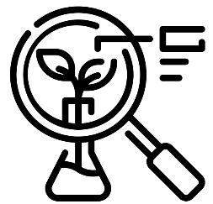


Science – Livings things and their habitats (Year 5)
Outcome: Understand a variety of lifecycles and create a diary about butterfly metamorphosis

Prior learning
- Identify and describe the functions of different parts of flowering plants (Y3 -Plants)
- Explore the part that flowers play in the life cycle of flowering plants, including pollination, seed formation and seed dispersal. (Y3 - Plants)
- Recognise that living things can be grouped in a variety of ways. (Y4 – Living things and their habitats)
- Explore and use classification keys to help group, identify and name a variety of living things in their local and wider environment.(Y4 – Living things and their habitats)
- Recognise that environments can change and that this can sometimes pose dangers to living things. (Y4 – Living things and their habitats)

Ideas and inspiration:
Sir David Attenborough (Naturalist & TV Presenter)
Jane Goodall (Wildlife Researcher & Conservationist
who studied chimpanzees)

Enquiries
Identifying, grouping and classifying  -Classify animals according to their life cycle   | Observing over time  -Grow from cuttings and observe whether they grow roots/ stem/ leaf/ flower | Pattern seeking  -Generate questions,  such as:  Do larger mammals have longer gestation periods?  Do larger animals live longer? | Researching  -Generate questions to research the life cycle of a chosen animal

Vocabulary:
Reproduction: asexual reproduction, sexual reproduction, gestation, metamorphosis, gametes, tuber, runners/ side branches, plantlet, cuttings, embryo, adolescent, penis, vagina, egg, pregnancy, gestation.
Previously introduced vocabulary: life cycle, pollination, offspring, fertilise, fertilisation, sepal, filament, anther, stamen, pollen, petal, stigma, style, ovary, carpel, ovule, stem, bulb, roots, mammal, adult, baby, sperm, cells, live young
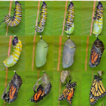
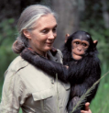





Developing Knowledge and Skills
Scientific Knowledge: |  | Working Towards | Within | Securely Within | Above
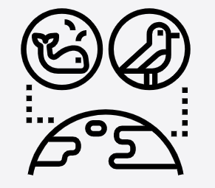 | - Describe the differences in the life cycles of a mammal, an amphibian, an insect and a bird.
 | - Describe the life process of reproduction in some plants and animals.
Working Scientifically: Do |  | Working Towards | Within | Securely Within | Above
 | - Use and develop keys and other information records to identify, classify and describe living things.
 | - Identify patterns that might be found in the natural environment
Working Scientifically: Record |  | Working Towards | Within | Securely Within | Above
 | - Record data and results of increasing complexity using scientific diagrams and labels, classification keys, tables.
Working Scientifically: Review |  | Working Towards | Within | Securely Within | Above
 | - Report and present findings from enquiries, in oral and written forms such as displays and other presentations.
 | - Use relevant scientific language and illustrations to discuss, communicate and justify scientific ideas
Highlights: ___________________________________________________________________________________
____________________________________________________________________________________________

